Angular With TypeScript

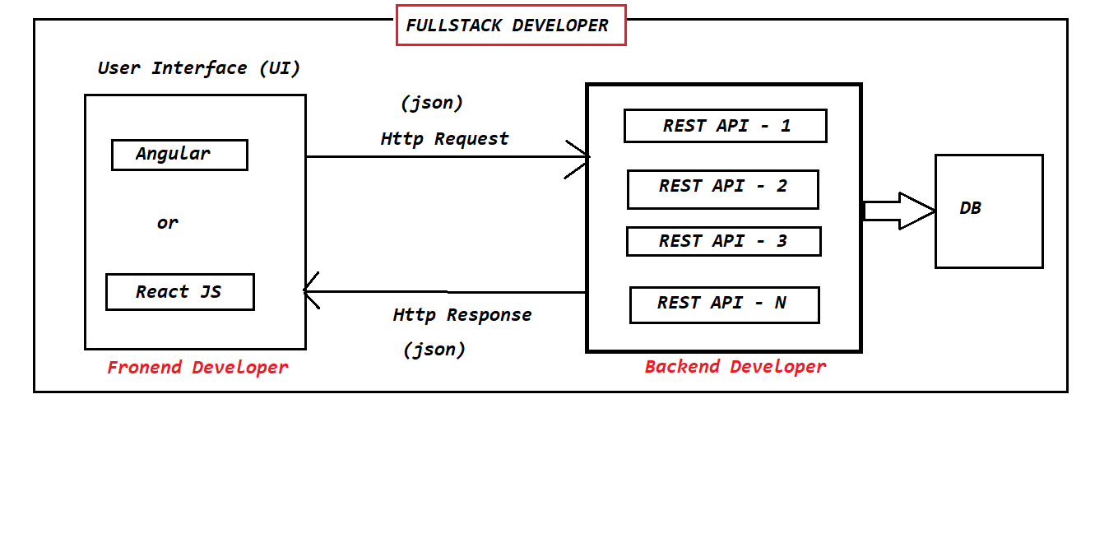
Full Stack Development, MPA and SPA

- Now a days in the industry companies are following Microservices architecture to develop the applications.

- Microservices is an Architectural Design Pattern which is used to develop our applications with loosely coupling and easy maintenence.

- As part of this Microservices architecture we will develop business logics as Rest Apis.

- REST APIS are for B 2 B communication (Business to Business Communication).

- Fullstack Development :Backend Development (REST apis) + Frontend Development (UI)

- As a fullstack developer we are going to develop web applications.

What is a web application?
- The application which runs in server is called as web application.

- Multiple users can access web applications at a time by using internet.

Ex: Facebook, Gmail, IRCTC etc.....

- We can see 2 types of web applications

- 1) Multi page web applications
- 2) Single page web applications

- In Multi page web applications for every request new web page will be loaded at client side. Here everytime entire page will be reloaded.

- In Single page web application web page will be loaded only for first request. From second request onwards only content will be updated without reloading the entire page.

What is Fullstack Development?
- As part of fullstack development we should develop backend Rest Apis and Front End user Interface.

- To develop backend rest apis we will use "Spring Boot & Microservices"

- To develop frontend user interface we will use below technologies

- HTML
- CSS
- Java Script
- BootStrap
- Angular or React JS

- The resouce who can develop both fronend and backend logics is called as Fullstack developer.

- Fullstack developers are having lot of demand in the market and companies are providing high packages for full stack developers.

What is Web Application?
- The application which runs in the server is called as Web Application.

- Multiple users can access web applications at a time.

- Ex : Gmail, Facebook, IRCTC, Net Banking etc...

- Now a days web applications are divided into 2 types

- 1) Multi Page Web applications (MPA)
- 2) Single Page Web applications (SPA)

- In Multi Page Web Application for every request new web page will be loaded at the client side.

- In Single Page web application only one web page will be available for every request just content will be updated without reloading the entire page.

- Ex : Gmail, angular.io etc....

Advantages of SPA

- Development will be easy

- Maintanance will be simple

- Good Performance

- Note: In single page application common content will be loaded only one time.

Angular Introduction

- Angular is a client side framework

- Angular is used to create Web Applications

- Angular is mainly used for Single Page Applications Development.

- Angular supports all platforms (Desktop and Mobile)

- Angular is free & open source

- Angular is having cross-browser compatability

- Angular developed by Google.

Angular JS and Angular Framework

- The intial version of Angular is called as Angular JS (Angular 1.x verions) which is developed by using Java Script.

- After few days Google realized the problems with Angular JS then they started developing one new framework to develop web applications thats where Angular Famework came into Market. This Angular framework is developed by using Type Script.

- From Version 2.0 onwards it is called as Angular Framework

- Angular 2.0 is not enhancement for Angular 1.0 because in 2.0 version Google Developers completely re-written Angular framework by using TypeScript.

- TypeScript developed by Microsoft Company.

- Angular 2+ versions are extensions for Angular 2.0 version

- Angular 1.x versions are called as Angular JS

- Angular 2.0 and later versions are called as Angular Framework versions

- The current version of Angular is 12 (Latest version released in Nov-2020)
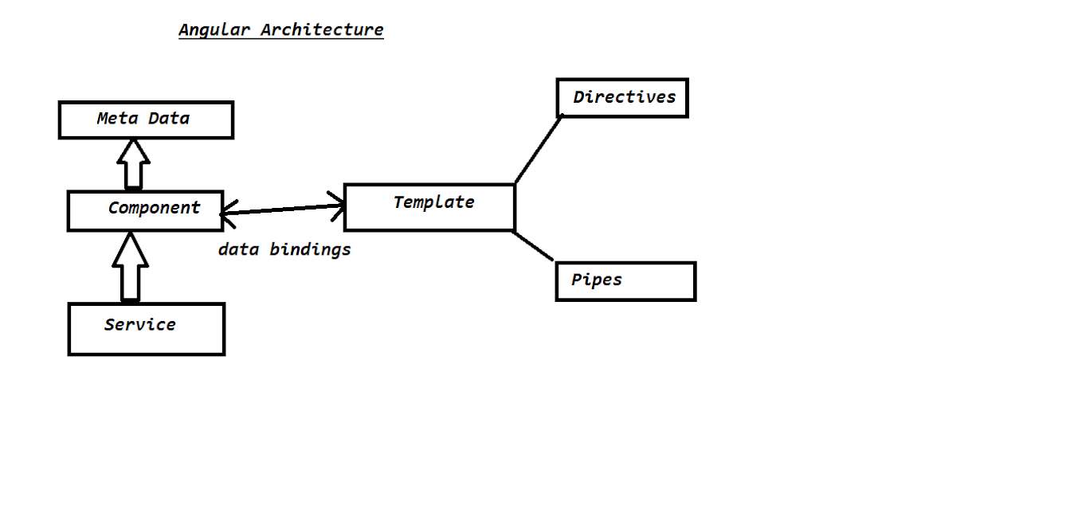
- Angular is a client side framework

- Angular is used to create Web Applications

- Angular is mainley used to develop Single Page Applications

- Angular framework is free and open source

- Angular framework developed by Google.

There are 2 flavours of Angular

1) Angular JS (Angular 1.x)
2) Angular (Angular 2+ versions)

- Angular JS is developed using Java Script

- Angular framework is developed by using Type Script

Note: Angular framework is completley re-written by google in Angular 2.0 version

- Angular is not extension for Angular JS (Angular is completley different from Angular JS)

Angular Architecture

1) Component
2) Meta Data
3) Service
4) Data Bindings
5) Template
6) Directives
7) Pipes

- Component is a TypeScript class which acts as Request Handler

- Meta Data Describes Component and Template mapping

- Service is a TypeScript Class which is used to write business logics

- Data Bindings are used for tranferring the data from component to template and from template to component.

- Template is a HTML file which contains presentation logic

- Directives are used for DOM manipulations

- Pipes are used to transforming the data from one format to another format.
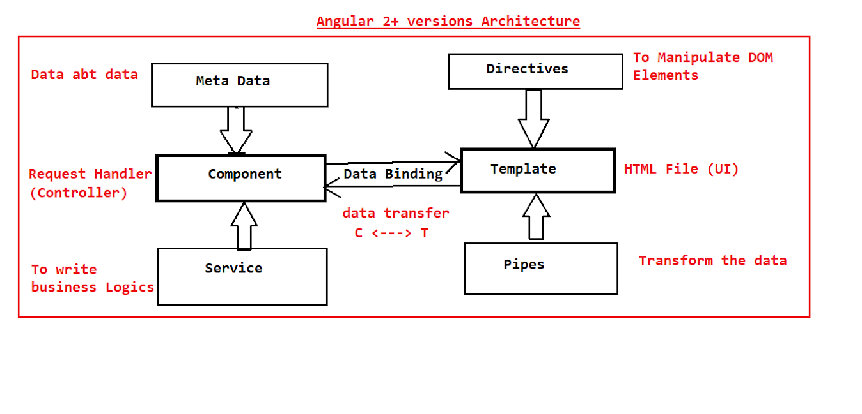
- Angular is a client side framework

- Angular is used to develop single page applications
- Ex : gmail, angular.io

- Angular is free & open source

- Angular is Developed By Google

- The current version of Angular is Angular-11

- Angular framework is developed by using TypeScript

- Angular JS is developed by using Java Script

- Angular framework is not extension for Angular JS

- TypeScript is a programming language which is developed by using Java Script.

- TypeScript is superset of java scirpt which adds data types + classes + Interfaces etc...

- TypeScript can be used for both client side programming and server side programming.

- TypeScript developed by Microsoft company in 2012.

Type Script : It is a super-script of Java Script , it provides all oop concepts and every Type-script file will convert to java-script file because browser can understand only java-script files.It is a strongly typed language (it is having different data types).

Transpilation : The process of converting ts file to js file.

Features of TypeScript

- TypeScript is general purpose programming language

- TypeScript built on top of java script

- TypeScript supports all features of java script and it is providing some additional features (data types, classes, objects, interfaces, modules etcc).

Note: Java Script can be executed in browser directley where as Browser can't execute TypeScript Directley.

- Typescript files should be converted into java script.

- The process of converting TypeScript file into JavaScript is called as "Transpilation".

file.ts ---- tsc --- file.js -- browser -- output

TypeScript Versions :

TypeScript 0.8 : 2012 (Intial Version)
TypeScript 4.x : 2020

Static Typing & Dynamic Typing
Whenver we can fix a data type for the variable while declaration of the variable and we can't change its datatype throughout the program then it is called as "Static Typing"

int age = 20; //valid

age = "20 Years" ; //in-valid

Ex : C, C++, Java, C#.Net are the examples for Static Typing languages

If we can't fix data type for the variable while declaration and the data type will be automatically taken by the runtime engine at the time of program execution then it is called as "Dynamic Typing".

var age;
age = 20 ; //valid
age = "20 Years" ; //valid

Ex : JavaScript and Python are examples for Dynamic Typing Languages

TypeScript supports "Optional Static Typing". It supports both 'Static Typing' and 'Dynamic Typing'.

TypeScript maintains Type Safety. If we specify data type while declaring the variable and if we assign wrong type of value into variable then compiler shows error.

Angular CLI Installation Process:

Development Environment
- Node
- Npm
- Angular CLI
- Text editor- visual code
Step 1
Open a browser type https://nodejs.org/en/ download, and install node js based on your window bit.
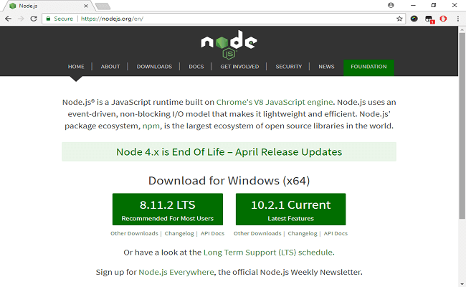
Step 2
After installing node js, open command prompt type node –v to check installed version of node js.
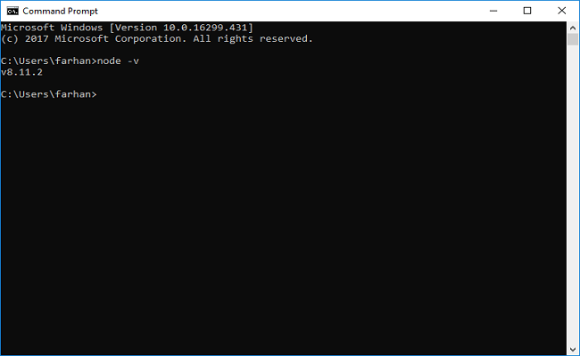
Type npm –v to check npm version. If both the commands show their respective versions it means node is installed successfully.
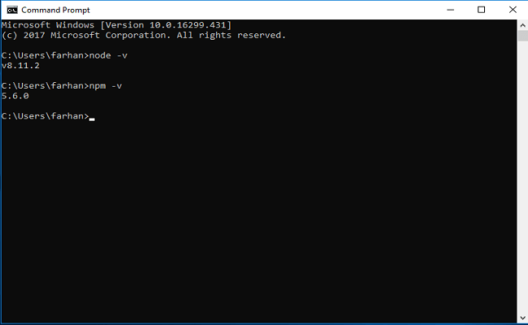
Step 3
Open browser type https://cli.angular.io/ check command to install Angular CLI.
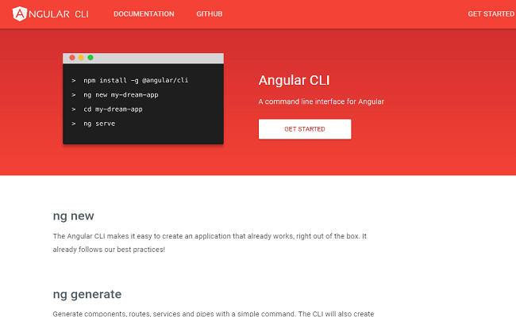
Step 4
Open command prompt, type command npm install –g @angular/cli. It will install CLI globally where g represents globally. To check Angular CLI installed type command ng –v
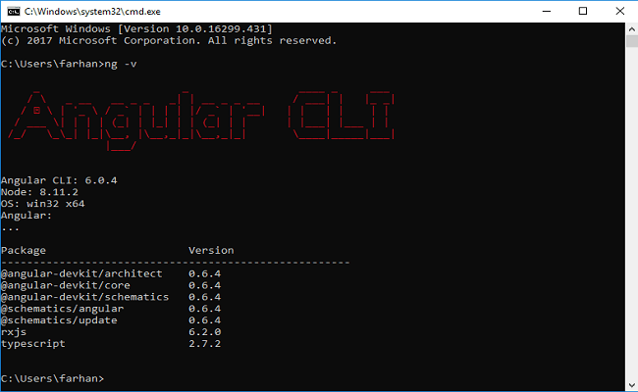
Step 5
Open command prompt type npm install –g typescript, it will install TypeScript in your system. Now type tsc –version in command prompt to check the version of typescript installed.
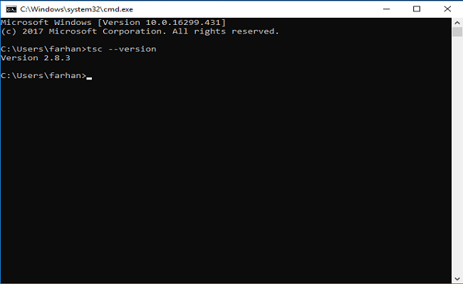
Step 6
Open browser, type https://code.visualstudio.com/ download, and install visual code editor.

Type Script

- Type-Script is a super set of Java-Script which means it builds on top of Java-Script by adding new features and Advantages to Java-Script.
- Browser can understand Java-Script only so that’s why we will convert Type-Script files into Java-Script which is called Transpilation.
- The key difference is Java-Script uses dynamic types (which are resolved at run-time) but Type-Script uses static types (which are set at the time of development)

- To install Type-Script
- > npm install -g typescript
- To Check Version
- >tsc -v (or) tsc -version

Type-Script Features

- Types
- Non-Java-Script Features like Interfaces & Generics
- Meta-Programming features like Decorators
- Rich Configuration Options

Plug-in’s

- 1.EsLint For Code Quality and Linting issues
- 2.Material Icon Themes For Files Icons
- 3.Path Intellisense For Great Importing Support
- 4.Prettier For Code Format

- TypeScript supports for OOPS also.

- TypeScript is general purpose programming language.

- TypeScript is superset of java script.

- TypeScript programs can't be executed in browser directley

- TypeScript program should be converted into java script using TypeScript Compilor.

- The process of converting TS file into JS file is called as Transpilation.

- JS file we can execute in command prompt using node

- JS file we can execute using HTML also

- In Realtime we will develop our front end applications using VS Code IDE

var s:string = "Hello World"; // String s = "Hello World";
console.log(s); //System.out.println(s);

Open Cmd and compile typescript file

tsc <filename>.ts

Note: Tsc compiler will covert ts file into js file (Transpilation)

Run js file using node with below command

node <filename>.js

The above program should print Hello World in console

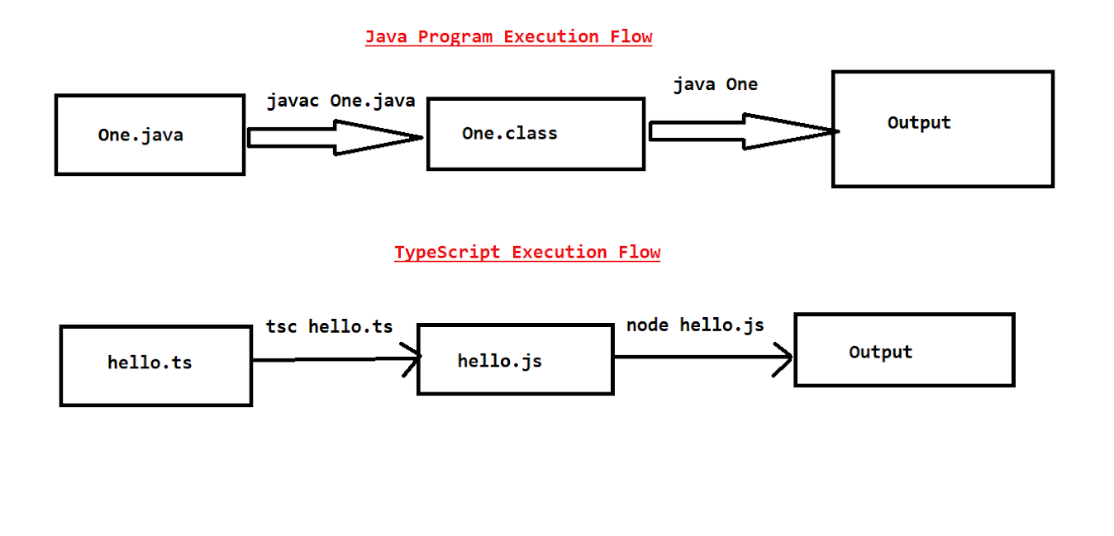
- TypeScript is a general purpose programming language.

- TypeScript is superset of java script

- We can use TypeScript at client side development and at server side development also

- Java Script doesn't support for data types where as TypeScript support for Data types.

- We can't execute Typescript file directly in browser.

- TypeScript file should be converted into Java Script file then we can execute in browser directley.

- The process of converting TypeScript file into java script file is called as Transpilation.

- TypeScript provided compiler (TSC) it is used to perform "Transpilation".

- Visual Studio Code IDE given by Microsoft (Free of cost)

Variables In TypeScript

- Variables are used to store the value

- Variable is a named memory (Every variable will have a name and will occupy some memory)

Syntax : var variableName:dataType = value;

Ex : var age:int = 20; //variable in typescript

int age = 20; //variable in java

DataTypes

Data Type specifies what type of value that can be stored into variable.

TypeScript DataTypes

1) number
2) string
3) boolean
4) any

number : For all types of numbers

Integer and Floating numbers can be represented by using number datatype.

Ex : 100, 150.56

string : Collection of characters in double quotes or in single quotes

Ex : "hello" & 'hi'

boolean : true or false

any : Any type of value we can store

var pname:string = "Ashok";
var age:number = 26;
var gender:string = "Male";
var isEmployeed:boolean = true;

console.log(`Name = ${pname}, Age = ${age}, Gender = ${gender}, IsEmployee = ${isEmployeed} `);

DataTypes : DataType are used to specify type of data that we can store into variable.

In TypeScript we have below 4 data types

1) number
2) string
3) boolean
4) any

Variable is used to store the value

Syantax : var variableName:dataType = value;

var age:number = 20;
var name:string = "ram";
var isEmp:boolean = false;

var variableName:dataType = value;
let variableName:dataType = value;
const variableName:dataType = value;

Arrays in Type Script

- Arrays are used to store group of values

- In TypeScript Arrays size is not fixed. We can store as many values as we want. (No limitation on size)

- In TypeScript arrays can store hetereogenious values also

let fruits:string[];

fruits = ['mango', 'apple', 'banana', 'orange'];
Functions

- Functions are primary building blocks of any program.

- In Java Script, Functions are very important bcz java script itself is a functional programming language.

- Functions ensure that the program is maintainable and resusable

- TypeScript supports for both functions and OOPS.

- In TypeScript, functions can be of two types

1) Named functions (function which contains a name)
2) Anonymous functions (function without name)

--------------------------Named function-------------------------------

function welcome(){
console.log("Welcome to Ashok IT");
}

welcome( );

Function can have a parameter and can have a return type also

function add(x:number, y:number) : number {
return x + y;
}

let result = add(10,20);
console.log("Sum ::"+result);

Anonymous Function.

- The function which doesn't contain any name is called as an Anonymous function.

Anonymous function is the one which is declared as an expression

let result = function (x:number, y:number) : number {
return x+y;
}

result(10,20);

----------------------------Working Example-------------------------------------
function doWork(x:number, y:number): number {
return x + y;
}
let result = doWork(10,20);
console.log("Result Of N.F :: "+ result);

let sum = function (x:number, y:number) : number {
return x + y;
}
let value = sum(30,40);
console.log("Result Of A.F :: "+ value);

Types Of Functions

- Function with Parameters
- Function with Return Type
- Function with Parameters & Return Type
- Function with optional parameters
- Function with default parameters
- Function with Rest Parameters (var-args)

Function with Parameters

- In Typescript function can take parameters

- Parameters are the values or arguments which we will supply to function as input

function fullName(fname:string, lname:string) : string {

return fname+" "+lname;
}

fullName("Ashok"); // Invalid - Function expecting 2 args but passed 1

fullName("Ashok", "IT", "School") ; // Invalid - Expected 2 args
but passed 3

fullName("Ashok", "IT") ;; // valid

Optional Parameters

- In TypeScript we have optional parameter functionality

- Optional Parameter should be the last argument

- Optional Parameter will be represented using ?

Rest Parameters

- Rest Parameters are similar to varargs in java

- If we don't know how many parameters we need to take for a function then we can simply use Rest Parameters

function(msg:string, ...names:string[]){
//logic
}

Note: Rest Parameter should be the last parameter of the function.
----------------------------------------------------------------------------------

function greeting(msg:string, name?:string) : string {
return name + " "+ msg;
}
console.log(greeting("Good Afternoon", "Ashok"));
console.log(greeting("Good Afternoon"));

function wish(name:string, msg:string="Hi") : string {
return name + msg;
}
console.log(wish("Ashok", "Hello"));
console.log(wish("Ashok"));

function greet(msg:string, ...names:string[]){
console.log(msg + "--"+names.join(","));
}
greet("Good Afternoong", "Ashok", "Ram", "Raj");
greet("Good Afternoong", "Ashok", "Ram", "Raj", "Bharat", "Chanti", "Suresh");

//Function With No Parameters
function wish(){
console.log("Hello Pavan")
}

//Function with Parameters
function add(a:number , b:number){
console.log('a+b=',(a+b));
}

//Function With Parameters and Return Type
function concat(str1:string,str2:string){
return str1+str2;
}

//Optional Parametes Function
function join(name?:string,age?:number){
return name;
}

//Default Parameters Function
function register(name:string,gender='Male'){
console.log('name=',name,'gender=',gender);
}

//Rest Parameters Functions

function registerNames(...names:string[]){
console.log(names);
}

wish();
add(10,12);
console.log(concat("Pavan","Janapati"));
console.log(join("Pavan"));
register("Pavan");
registerNames("Pavan","Naveen","Srikanth");

- OOPS stands for object oriented programming system

- In OOPS programming languages "Classes" are fundamental entities which are used to create re-usable components.

- "Class" is a plan or model which is used to create the object.

- "Object" is a physical entity which is used to store the data.

Class contains following things
-------------------------------
1) Fields / Properties : Variables declared in class

2) Methods : To perform action

3) Nested Class : A class can contain another class

4) Constructor : It is used to initialize the object

5) Object : Physical item or collection of properties

Syntax to declare class in TypeScript
-------------------------------------
class <class-name> {

//fields

//methods
}

Example for class
------------------
class Student {

let studentName : string ;
let studentRank : number ;
let studentMarks : number ;

getStudentGrade ( ) : string {
//logic
return grade;
}
}
-------------------------------------------Student.ts----------------------------------------
class Student {

studentName: string;
studentRank: number;
studentMarks: number;

getStudentGrade() : string {
if(this.studentMarks >= 75 ){
return "A";
}else if(this.studentMarks >=65 && this.studentMarks < 60){
return "B";
}else{
return "C";
}
}
}

let s1 = new Student(); //obj creation
s1.studentName = "John";
s1.studentMarks = 50;
s1.studentRank = 3;

console.log("Grade :: "+ s1.getStudentGrade());

let s2 = new Student() ; //obj creation
s2.studentName = "Smith";
s2.studentMarks = 90;
s2.studentRank = 2;
console.log("Grade :: " + s2.getStudentGrade());
----------------------------------------------------------------------------------------------

Constructors in TypeScript

Constructor is a special function which is part of the class.

Constructor is used to initialize the object.

Constructor name will be same as Class Name.

In constructor we can access class members using 'this' keyword

When we create object for a class constructor will be called automatically.

Constructor will take arguments but it can't return anything.

**** In TypeScript, Constructor doesn't support for overloading ****

**** In TypeScript, we will use 'constructor' keyword to define constructor *****

-------------------------------User.ts-------------------------------------------------------
class User{
userId : number;
userName : string;

constructor(userId : number, userName:string){
this.userId = userId;
this.userName = userName;
}
}

let user = new User(101, "Ashok");
console.log("user id :: "+ user.userId);
console.log("username :: "+user.userName);

- Class is a plan or model which is used to create the object

- Object is a physical entity which is used to store the data

- Constructor is a special function which is used to initialize the object

- Access modifiers specify weather the members of the class can be accessible or not.

- Access modifiers are used to achieve security in OOPS.

- TypeScript supports 3 access modifiers

1) public
2) private
3) protected

- public members of the class are accessible anywhere in the program. public members can be accessible inside the class and outside the class also.

- private members of the class are accssible only with in the same class. If we try to access private members outside of the class then we will get compiletime error.

- protected members are accessible with in the same class and in corresponding child classes also.

Syntax for creating class members with Access Modifiers
---------------------------------------------------------
class <class-name> {
accessmodifier propertyName : dataType ;
accessmodifier functionName : returnType {
//body
}
}
-------------------------------------------------------------------------
Interfaces

- Interface is the one which contains only abstract methods and properties

- The method which doesn't contain body is called as abstract method

- In Interface we will write only method declarations. Interface doesn't contain method implementations.

- To implement an interface, class will use "implements" keyword.

- When a class is implementing an interface, its mandatory that all methods of interface should be implemented in that class.

- Interface methods are by default public.

- One interface can be implemented by multiple classes.

- One class can implement multiple interfaces also

************ Interfaces are called as contracts ****************

Syntax For Interface Creation
-----------------------------
interface InterfaceName{
property : dataType ;
method(args) : returnType ;
}

Implementation class for Interface
-----------------------------------
class ClassName implements InterfaceName {
property : dataType ;
method(args) : returnType {
//method implementation here
}
}

TypeScript - Modules

- In Large applications we will have multiple classes

- It is highly recommended to write each class in a seperate file.

- To access the class of one file in another file we will use Modules concept in TypeScript.

- Module is a file (ts file) which can export one or more classes to other files.

- To export a class we will use 'export' keyword (source file)

- To import a class we will use 'import' keyword (desitnation file)

------------------------------- Student.ts----------------------------------------
export class Student {

studentId : number;
studentName : string;

constructor(id:number, name:string){
this.studentId = id;
this.studentName = name;
}
}
-------------------------------School.ts------------------------------------------
import {Student} from "./Student" ;

class School{

students : Student[] = [
new Student(101, "John"),
new Student(102, "Smith"),
new Student(103, "Nick")
];

display() : void {
for(var i in this.students){
console.log(this.students[i]);
}
}
}

let school:School = new School();
school.display();
------------------------------------------------------------------------------------------------

- If we want to use class/interface/enum of file in another file then we will use Modules concept.

- To work with modules we will use export and import options.

- TypeScript is a programming language which is developed based on java script.

- TypeScript is superset of java script.

- TypeScript built on top of Java Script

- TypeScript can't execute directley in browser.

- TypeScript file should be converted into java script file using TypeScript compilor that is called as 'Transpilation'.

If you get an error, there is an issue with your Angular CLI version. I recommend you install CLI version 6.0.3. Here are the steps:
- npm uninstall –g @angular/cli
- npm install –g @angular/cli@6.0.3
Commands to generate Component,Service,Pipe

- ng generate component <name>
- ng generate service <name>
- ng generate pipe <name>
- ng g c data-binding --flat --skipTests

- To stopt creating folder for component --flat
- To skip Test file creation --skipTests

Use of Node Js :

- Angular does not need node.js directly. Node js is used for all the build and development tools.Angular is a framework and you may use typescript programming language to program us. Typescript is the most popular choice. A web browser such as Chrome, Firefox or Internet Explorer understands only Javascript so we have to transpile our Typescript to Javascript and for that we use typescript transpiler which requires NodeJS.

- Angular need Node j because run the JavaScript code outside the browser. Due to this reason we use Node js with angular.

- Angular doesn't need Node directly but Node gives the npm tool to download packages and libraries, which you may use in your Angular application. In other words, Node is mainly used for build and development tools.

- npm allows us to install & download open source js libraries in our system(They are integrated with node-js.

- Angular TS is based on Component and Service Architecture.

Angular

- Angular is a platform and framework for building single-page client applications using HTML and TypeScript. Angular is written in TypeScript.It is a front-end framework it makes easy to build applications for both web and mobile.

Angular CLI :

- The Angular CLI is a command-line interface, it provides schematics & commands to build our application fast.

Ex:
schematics : ng serve,
commands : ng g c <comp-name>.

- Angular is a client side framework which is used to create web applications.

- Angular is developed by using TypeScript

- Angular developed by Google company

- Angular is free & open source

- Angular is cross platform (It works in all operating systems)

- Angular is cross browser compatible (It works in all browsers)

- Angular is mainley used for Single Page Applications Development (SPA)

Multi Page Application vs Single Page Application

- In Multi page application for every request web page will be reloaded

- In signle page application for every request only content will be re-loaded.

Building Blocks of Angular

1) Component : Application state + Application logic

2) Metadata : Details about component / Module

3) Template : View File (Presentation logic) - HTML

4) Databinding : Connection between HTML elements and Component properties

5) Module : Group of Components, Directives and Pipes

6) Service : Re-usable business logic

7) Dependency Injection : Injecting service objects into components

8) Directives : To manipulate DOM elements

9) Pipes : Transforming values before displaying

- Angular is a framework which is used to develop web applications

- Angular is given by Google

- Angular is open source and free

- Angular supports cross platform

- Angular support cross browsers

- Component is a typescript class which is responsible to handle requests coming from template.

- Template is a html file which contains presentation logic

- Databinding is used to bind the data between component and template. Component properties will be binded to HTML elements for data binding.

- Service is a Typescript class which contains re-usable business logic.

- Dependency Injection is used for Injecting Service class obj into Component class obj.

- Data about the data is called as Meta Data. Relation between component and template will be maintained in meta data.

- Directives are used to manipulate DOM elements

- Pipes are used to transform the data before displaying in template.

- Collection of components is called as Module

- Routings are used to navigate from one page to another page.

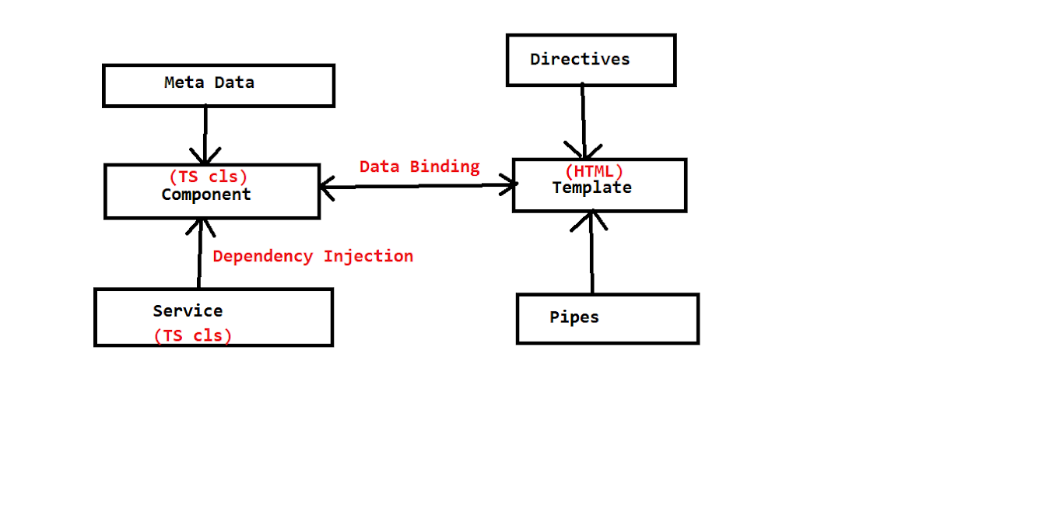
- To create angular application execute below command in command prompt

ng new <app-name>

- Once application got created, nagivate into application folder and execute below command to run angular application.

ng serve

- Angular applications will be deployed into live server which runs on port number 4200. Once angular application deployed into live server then we can access using below URL

http://localhost:4200/

- When we create angular application by default 'app-component' will be created.

- 'app-component' will be called as Parent component in the angular application.

- Angular application execution will begin from 'app-component' only

app.module.ts
app.component.ts --- logic to handle request
app.component.spec.ts - Unit testing logic
app.component.html - template( presentation logic )
app.component.css - styles will write here

Angular application folder structure

- To develop angular applications we are using VS Code IDE

ng new <app-name>

ng serve

http://localhost:4200/

package.json

- The package.json file represents the configuration settings/meta data of the application.

- angular application dependencies will be configured in package.json file

- In package.json file we will have 'dependencies' and 'dev-dependencies'

- 'dev-dependencies' are used for developing angular application and 'dependencies' are used for running the angular application.

Angular packages

@angular/core
@angular/common
@angular/compiler
@angular/platform-browser
@angular/platform-browser-dynamic
@angular/forms
@angular/router
@angular/http
@angular/material
@angular/cli

tsconfig.json file

- It is used to set configuration settings for typescript compiler.

- Typescript compiler will read tsconfig.json and then it compiles all .ts files into .js files.

tslint.json

- This file contains configuration settings for 'lint' tool which is used to verify weather the typescript files are following a set of coding standards or not

karma.conf.js

- This file contains configuration settings for 'karma' tool which is used to execute unit test cases on multiple browsers

angular.json

- This file contains configuration settings for "@angular/cli" tool which is used for create, compile and run angular applications.

- It contains settings such as home page (index.html), startup file (main.ts), css file (styles.css) etc.

src/styles.css

- This file contains cascading styles which are applicable for entire application.

src/index.html

- This file is home page (startup page) for entire application.

- The content of entire application will be displayed in index.html file only.

Start Up Module In Angular

- Angular application can contain any no.of modules

- Angular application execution will begin from 'App Module'.

- 'App Module' is called as 'Startup Module' of angular application.

- The process of executing startup module is called as 'Boot Strapping'.

- Syntax : platformBrowserDynamic().bootstrapModule(AppModule)

What is Component?

Components are the main building block for Angular applications. Each component consists of:
- An HTML template that declares what renders on the page
- A Typescript class that defines behavior
- A CSS selector that defines how the component is used in a template
- Optionally, CSS styles applied to the template

Ans) Component represents certain section in web page.

For Example "Login Form" will be represented by "Login Component". "Registration Form" will be represented by "Registration Componenent".

Q) How to create Component in angular application ?

Ans) To create a new component we will use below syntax in angular cli.

ng generate component <component-name>
or
ng g c <component-name>

Ex : ng g c login ==========> login component will be created

Q) What all files will be created in component?
Ans) When we create a component below 4 files will be created.

<component-name>.component.ts -------- (properties & methods)
<component-name>.component.html --- (presentation)
<component-name>.component.css ---- (styles)
<component-name>.component.spec.ts --------(unit testing)

<component-name>.component.ts file is a typescript class in that we will write variables and methods to deal with requests.

properties ------------------ To store the data
methods --------------------- To perform action

Note: In Angular application we can create any no.of components. "app component" is the mandatory component.

Q) How to invoke a component in web-page?
Ans) A component can be invoked using 'selector' tag. We can find selector tag in component.ts file.

Q) How to represent type script class as Component?
Ans) To represent Type Script class as Component we will use @Component decorator.

Syntax To create Component
---------------------------

import {Component} from "@angular/core";

@Component
class ClassName{

property:dataType = value;

method(args) : returnType {
//logic
}
}

Metadata properties of @Component
-----------------------------------
@Component({
selector : 'app-root',
templateUrl : './app.component.html',
styleUrls : ['./app.component.css']
})

- 'selector' represents a tag which is used to invoke the component.

- 'templateUrl' represents html file that has to be rendedred when the component is invoked.

- 'styleUrls' represents css styles that should be loaded for template.

- If we want to write the presentation logic in same ts file then we have to do like ..

template: `<h1>Hello</h1>`,

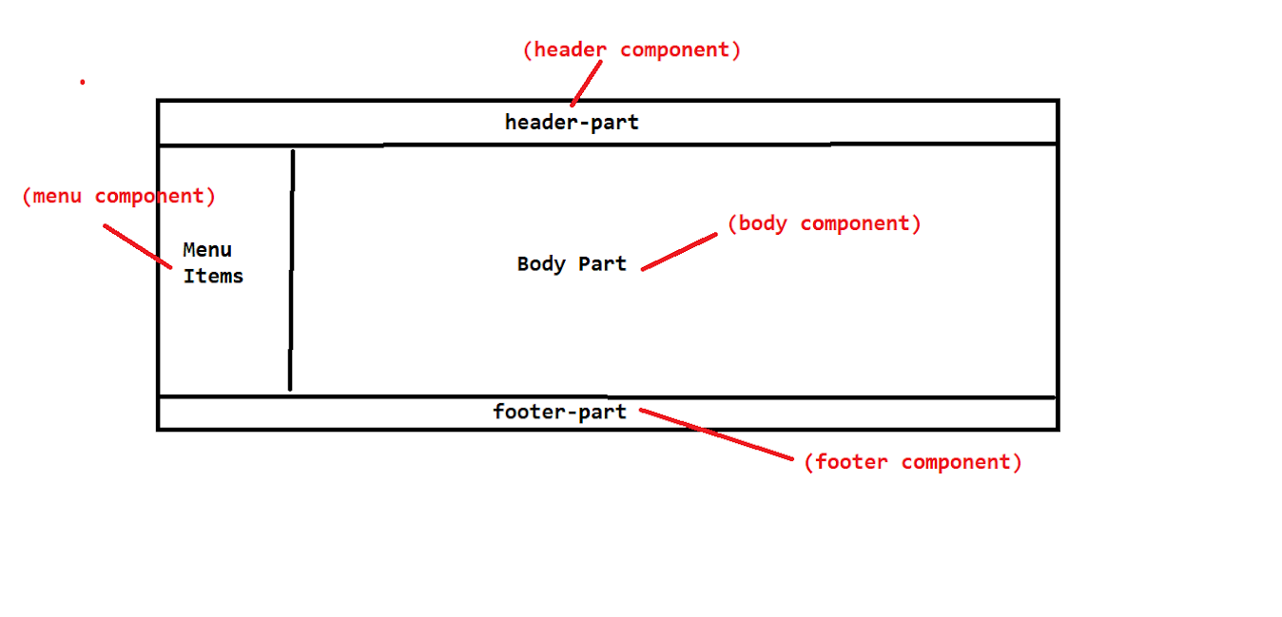
Directives : It is a function , it is used to convert static DOM element into dynamic DOM element.

- Directives are classes that add additional behavior to elements in your Angular applications. With Angular's built-in directives, you can manage forms, lists, styles, and what users see.

- Directives are used to manipulate DOM elements.

- DOM stands for Document Object Model
The different types of Angular directives are as follows:
- Components—directives with a template. This type of directive is the most common directive type.
- Attribute directives—directives that change the appearance or behavior of an element, component, or another directive.
- Structural directives—directives that change the DOM layout by adding and removing DOM elements.

Angular Framework provided several Built-in Directives

- ngStyle -- adds and removes a set of HTML styles.
- ngClass -- adds and removes a set of CSS classes.
- ngModel -- adds two-way data binding to an HTML form element.
- ngIf—conditionally creates or disposes of subviews from the template.
- ngFor—repeat a node for each item in a list.
- ngSwitch—a set of directives that switch among alternative views.

- 'ngStyle' directive is used to set CSS property value dynamically at runtime. When the value of the component property is changed the value of css property will be changed automatically.

- 'ngClass' directive is used to set CSS classname dynamically at runtime. This directive is used to set styles with multiple properties, conditionally at runtime.

- 'ngIf' is used to display an element when condition is 'true'.

- 'ngIf and else' is used to display one element when condition 'true' and display another element when condition is 'false'.

- 'ngSwitch' is used to display content based on variable value matched with a case.

- 'ngFor' is used to execute logic repeatedly (in a loop)

Directives can be used as ,
i . Element
Ii . Attribute
Iii . Class
Iv . Comment

I . Element : returns markup

Ex : <ng-template></ng-template>

---> ng-template is an Angular element used to render HTML templates. We use ng-template with angular *ngIf directive to display else template.

II . Attribute : extends markup
Ex : <input type="checkbox" name="flag" #flag="ngModel" ngModel >

III . Class : To make markup more interactive
Ex : .ng-valid , ng-pristive

IV . Comments : To run on legacy browsers
<! #txtName = “ngModel” -->

In Angular we have three types of Directives ,

- Component Directives
- Structural Directives
- Attribute Directives

a . Component Directives : Component Directive is Comprises of Presentation , Logic , Styles . It is for re-usability of component.
Ex : <app-login></app-login>

b . Structural Directives : These are for changing the DOM structure like adding , removing , repeating the element dynamically
Ex : ngIf ,ngFor , ngSwitch

--> ngIf : add or remove DOM element , it uses boolean value or condition
--> ngIf without else example
MVVM
<input type="checkbox" name="flag" #flag="ngModel" ngModel >
<div *ngIf="flag.value"> Pavan Hi</div> -->

MVC
<input type="checkbox" [(ngModel)]="flag" >
<p>{{flag}}</p>
<div *ngIf="flag"> Pavan Hi</div>

Examples:
Product.component.html
<h1 >Product Details</h1>

<div style="background-color: yellow;">
<div>
{{products.name}}
</div>

<div>
{{products.price}}
</div>

<div>
<img [src]="products.photo" width="50px" height="50px" *ngIf="displayImage">
</div>

<div>
{{products.inStock}}
</div>

<div>
<input type="button" (click)="previewClick()" value="preView">
</div>
</div>

Product.component.ts

products ={
name : 'Jeans',
price : 1200,
photo : 'assets/jeans.jpg',
inStock :true,
}

displayImage = false;

previewClick(){
this.displayImage = true;
}

Example 2:
<dt style="color: green; text-align: center; font-size: 20px; background-color: yellow;">Employee RegistartionForm</dt>
<dd><label>Enter Name</label></dd>
<dd>
<input required type="text" name="ename" ngModel #ename="ngModel">

<span *ngIf="ename.invalid " style="color:red">* name required </span>
</dd>
Example 3 :

selectedCategory: string= "All"
constructor() { }

categories:string[]=['All','Fashion','FootWear'];

products =[
{name : 'Jeans', price : 4200, photo : 'assets/jeans.jpg',inStock :true,category : 'Fashion'},
{name : 'TShirt',price : 1100,photo : 'assets/tshirt.jpg',inStock :true,category : 'Fashion'},
{name : 'SParx', price : 1500.45, photo : 'assets/shoe1.jpg',inStock :true,category : 'FootWear'},
{name : 'Reebok',price : 3400.50,photo : 'assets/shoe2.jpg',inStock :true,category : 'FootWear'}

]

<div>
<select [(ngModel)]="selectedCategory" >
<option *ngFor="let item of categories">{{item}}</option>
</select>
</div>

<div>
<table bgcolor="cyan" align="center" border="2px">
<thead>
<th>Name</th>
<th>Price</th>
<th>Photo</th>
<th>InStock</th>
<th>Category</th>
</thead>

<tbody *ngFor="let item of products">
<tr *ngIf="selectedCategory == 'All' || item.category == selectedCategory ">
<td>{{item.name}}</td>
<td>{{item.price}}</td>
<td><img [src]="item.photo" width="40px" height="50px"></td>
<td>{{item.inStock}}</td>
<td>{{item.category}}</td>
</tr>

</tbody>
</table>

</div>

ngIf with Esle :

<div *ngIf="false ; else msg">

Hello Pavan

</div><p></p>

<ng-template #msg>
I am else block
</ng-template>

ngIf with then and else :

<div style="background-color: greenyellow;align-content: center; width: 200px;margin-left: 200px;padding-left: 40px;">

<label>Select True or False</label>
<dd>
<input type="checkbox" [(ngModel)]="msg">
</dd>
</div>
<div *ngIf="msg ;then trueBlock ; else falseBlock">

</div>

<ng-template #trueBlock>
I am true block
</ng-template>

<ng-template #falseBlock>
I am false block
</ng-template>

ngSwitch :

<div style="background-color: yellowgreen;border: 2px solid green; width:200px;margin: auto;">
<ul>
<li><input type="button" (click)="onButtonClick($event)" value="preview"></li>
<li><input type="button" (click)="onButtonClick($event)" value="details"></li>
<li><input type="button" (click)="onButtonClick($event)" value="description"></li>
</ul>
</div>

<div [ngSwitch]="value">
<div *ngSwitchCase="'preview'">
<img src="assets/jeans.jpg" width="300px" height="300px">
</div>
<div *ngSwitchCase="'details'">
<p>It is made in England</p>
</div>
<div *ngSwitchCase="'description'">
<p>It is a levi's brand Jean Pant</p>
</div>
</div>

export class NgSwithComponent implements OnInit {

constructor() { }

ngOnInit(): void {
}
onButtonClick(event){
this.value= event.target.value;
}
value:string;
}

Accessing ngFor Properties :

<div>
<h3 style="text-align: center;color: hotpink;">Employee Details</h3>
<table align="center" class="table" border="2px">
<thead >
<th>Id</th>
<th>Name</th>
<th>Salary</th>
<th>Location</th>
<th>Index</th>
<th>Even</th>
<th>Odd</th>
<th>First</th>
<th>Last</th>
</thead>

<tbody *ngFor="let employee of Employees;let index=index ;let even=even ;let odd=odd ; let first= first ;let last=last">
<tr style="width:100px ; height: 60px;" *ngIf="index % 2 == 0">
<td>{{employee.id}}</td>
<td>{{employee.name}}</td>
<td>{{employee.salary}}</td>
<td>{{employee.location}}</td>
<td>{{index}}</td>
<td>{{even}}</td>
<td>{{odd}}</td>
<td>{{first}}</td>
<td>{{last}}</td>

</tr>
</tbody>

</table>

</div>

Deleting row from Employee Details :

export class NgForComponent implements OnInit {

constructor() { }

ngOnInit(): void {
}

Employees=[
{id:1 , name:"Pavan" ,salary: 20000 , location : 'Hyderabad'},
{id:2 , name:"Naveen" ,salary: 23440 , location : 'Hyderabad'},
{id:3 , name:"Srikanth" ,salary: 25600 , location : 'Hyderabad'}
]

delete(index){
this.Employees.splice(index,1);
}

}

<div>
<h3 style="text-align: center;color: hotpink;">Employee Details</h3>
<table align="center" class="table" border="2px">
<thead >
<th>Id</th>
<th>Name</th>
<th>Salary</th>
<th>Location</th>
<th>Index</th>
<th>Even</th>
<th>Odd</th>
<th>First</th>
<th>Last</th>
<th>Delete</th>
</thead>

<tbody *ngFor="let employee of Employees;let index=index ;let even=even ;let odd=odd ; let first= first ;let last=last">
<tr style="width:100px ; height: 60px;" >
<td>{{employee.id}}</td>
<td>{{employee.name}}</td>
<td>{{employee.salary}}</td>
<td>{{employee.location}}</td>
<td>{{index}}</td>
<td>{{even}}</td>
<td>{{odd}}</td>
<td>{{first}}</td>
<td>{{last}}</td>
<td>
<button (click)="delete(index)"> <img src="assets/delete.jpg" width="40px" > </button>
</td>

</tr>
</tbody>

</table>

</div>

c . Attribute Directives :

These are used for applying the styles to the elements dynamically
Ex: ngClass , ngStyle

--> we can use three types of references for mentioning classes names
- String Reference
[ngClass]="'class'"
- Array Reference
[ngClass]="['class','myClass']"
- Object Reference boolean value
[ngClass]="{'valid':text.valid , 'inValid':text.invalid}"

<div>
<p [ngClass]="'class'">Hello Pavan</p>

<p [ngClass]="['class','myClass']">Hello Pavan How are You</p>
<label>Enter Name</label>
<input type="text" ngModel #text="ngModel" [ngClass]="{'valid':text.valid , 'inValid':text.invalid}" required minlength="4">
</div>

.class{
color:greenyellow;
text-align: center;
}

.myClass{
font-size: large;
}

.inValid{
border: 2px solid red
}

.valid{
border: 2px solid green
}

ngStyle
<div [ngStyle]="classes">Third Div</div>

<div [ngStyle]="{'background-color':getColour()}">Hello Pavan</div>

<div [ngStyle]="{'background-color':colorName}">Hello Pavan</div>

Data Bindings

- Data Binding is a technique which is used to establish relation between "component" and "template"

- Component is a typescript class

- Template is a html file

- By using data binding technique we can send data from component class to template file and vice versa.

DataBinding
component class <---------------> Template

If "component" is changed then template will be changed automatically. If "template" is changed then the "component" will be changed automatically.

- Data Bindings are four types

1) Interpolation
2) Property Binding
3) Event Binding
4) Two Way Binding

Interpolation

- It is used to display variable/property value in template

- If variable/property value is changed in component then immediatley it will be updated in the template.

Syntax : {{propertyName}}

Property Binding

- Property Binding is used to send the data from component to template and assign the same into an attribute of tag.

- If the property is changed then immediatley it will be updated in template.

Syntax : [attribute] = *property

Event Binding
- Event binding allows you to listen and respond to user actions such as keystrokes, mouse movements, clicks, and touches.

- It is used to pass event notification from template to component

Syntax : <tag (event) = "method()"> </tag>

<div>
<label>Enter Name</label> <input type="text" [(ngModel)]="userName">
<br>
<input type="submit" value="Save" (click)="submit()">
</div>
<p *ngIf="flag">Record Saved</p>

Two-Way Data Binding

- Two-way data binding is the combination of both property binding and event binding.

- To achieve Two-way data binding we have "ngModel" directive.

- Two-way data binding is applicable only for <input/> and <select/> tags.

- To use Two-way data binding we must import "Forms Module"

- Import "Forms Module" in app.module.ts file

- Declare properties and method(s) in app.component.ts file

- Write presentation logic in app.component.html file

-----------------------------------app.module.ts---------------------------------
import { NgModule } from '@angular/core';
import { FormsModule } from '@angular/forms';
import { BrowserModule } from '@angular/platform-browser';

import { AppComponent } from './app.component';

@NgModule({
declarations: [
AppComponent
],
imports: [
BrowserModule, FormsModule
],
providers: [],
bootstrap: [AppComponent]
})
export class AppModule { }

------------------------------------app.component.ts-----------------------------
import { Component } from '@angular/core';

@Component({
selector: 'app-root',
templateUrl: './app.component.html',
styleUrls: ['./app.component.css']
})
export class AppComponent {

name:string = "John";
age:number = 25;

handleSubmitBtn(){
this.name = "Smith";
this.age = 30;
}

}
--------------------------------app.component.html--------------------------------
<div>
<h4>Two-Way Data Binding Example</h4>

Name :: {{name}} <br/>
Age :: {{age}}

<hr/>

Name : <input type="text" [(ngModel)]="name"/> <br/>
Age : <input type="text" [(ngModel)]="age"/> <br/>

<input type="button" value="Submit" (click)="handleSubmitBtn()"/>

</div>

<h3 style="color:red">String Inter-Polation</h3>
<div>userName::{{name}}</div>

<h3 style="color:red">Property Binding</h3>
<p [style]="{color:colorName}">Hello</p>

<input type="text" [(ngModel)]="mobileNumber"><br>
<p>{{mobileNumber}}</p>

Decorators :

- Decorators are functions those will return functions.
- These are typescript features used for passing data.
- These are invoked at run time.
- These are allows us to invoke functions.

Types of Decorators :

- Class Decorators : @NgModule , @Component
- Property Decorators : @Input , @Output
- Method Decorators : @HostListener (Event Decorator)
- Parameter Decorators : @Inject

Decorators are starts with ‘@’ symbol.

Decorators have meta data and Deacorators are way to pass meta data to angular applications.

@Input Decorator : It is used for Passing data from parent to child component.

In parent.ts :
salary:number=20000

In parent.html :
<child-selector [paramName in child.ts]=”salary”></child-selector>

In child.ts :
@Input(‘paramName’) varName:any;

In child.html :
<b>varName</b>

@Output Decorator: It is used for passing data from child component to Parent Component by creating a custom event.

@Output decorator binds a property of a component to send data from one component (child component) to calling component (parent component). This is one way communication from child to parent component. @Output binds a property of the type of angular EventEmitter class. This property name becomes custom event name for calling component. @Output decorator can also alias the property name as @Output(alias) and now this alias name will be used in custom event binding in calling component.
Find the @Output decorator using aliasing.

@Output decorator is used to pass the data from child to parent component. @Output decorator binds a property of a component, to send data from one component to the calling component. @Output binds a property of the type of angular EventEmitter class.

In Parent.ts:

array : string[] = ['pavan','naveen','srikanth'];

myIncrement(event:any){
this.name=event;
}

In Parent.html :

<app-child *ngFor="let ele of array" [name]="ele" (salaryInc)="myIncrement($event)"></app-child>
{{name}}

In Child.ts :

@Input('name') name :any;

@Output('salaryInc') incSalary = new EventEmitter() ;
sendData(){
this.incSalary.emit(this.name);
}

In Child.html :

<button (click)="sendData()" > sendData</button><br>

@HostBinding ()& @HostListener () : @HostListener() is used to capture the event of a HostElement.

constructor(private el: ElementRef) {
this.el.nativeElement.classList.add('blue');
}

Custom Events :
--> We can create our own events , generally custom events are designed for custom components

--> when you design a component you can configure an custom event
-->Custom event emits the value outside component

ChildComponet.ts

import { Component, Input, OnInit } from '@angular/core';

@Component({
selector: 'app-child',
templateUrl: './child.component.html',
styles: [
]
})
export class ChildComponent implements OnInit {
@Input() data:any;
constructor() {
}
ngOnInit(): void {
}
}

ChildComponent.html

<div style="background-color: greenyellow; width:200px; height: 200px;">
<dt>Child Component</dt>
<ul>
<li *ngFor="let product of data">{{product.name}}</li>
</ul>
</div>

ParentComponent.ts

import { Component, OnInit } from '@angular/core';

@Component({
selector: 'app-parent',
templateUrl: './parent.component.html',
styles: [
]
})
export class ParentComponent {
constructor() { }
products =[
{name : 'Jeans', price : 4200, photo : 'assets/jeans.jpg',inStock :true,category : 'Fashion'},
{name : 'TShirt',price : 1100,photo : 'assets/tshirt.jpg',inStock :true,category : 'Fashion'},
{name : 'SParx', price : 1500.45, photo : 'assets/shoe1.jpg',inStock :true,category : 'FootWear'},
{name : 'Reebok',price : 3400.50,photo : 'assets/shoe2.jpg',inStock :true,category : 'FootWear'}

]
}

ParentComponent.html

<div style="background-color:cyan; width: 300px;height: 300px;">
<dt>Parent Component</dt>
<ul>
<li *ngFor="let product of products">{{product.name}}</li>
</ul>

<br>
<app-child [data]="products"></app-child>
</div>

- How a child Component can send data to Parent Component ?
It can Send data to parent component by using @Output Directive and EventEmitter

ParentComponent.ts

import { Component, OnInit } from '@angular/core';

@Component({
selector: 'app-parent',
templateUrl: './parent.component.html',
styles: [
]
})
export class ParentComponent {
name: string;
constructor() { }
recieveData(event){
this.name=event;
}
}

ParentComponent.html

<div style="background-color:cyan; width: 300px;height: 300px;">
<dt>Parent Component</dt>
{{name}}

<br>
<app-child (sendData)="recieveData($event)"></app-child>
</div>

ChildComponent.ts

import { Component, EventEmitter, Input, OnInit, Output } from '@angular/core';

@Component({
selector: 'app-child',
templateUrl: './child.component.html',
styles: [
]
})
export class ChildComponent implements OnInit {

@Input() data:any;
@Output() sendData:EventEmitter<string>=new EventEmitter<string>();
name:string;
constructor() {
}
onClick(){
this.sendData.emit(this.name);
}
ngOnInit(): void {
}
}

ChildComponent.html

<div style="background-color: greenyellow; width:200px; height: 200px;">
<dt>Child Component</dt>
<input type="text" [(ngModel)]="name">
<button (click)="onClick()" >send Data</button>
</div>

@Input() - To accept the data from parent Component
@Output - To emits the data to parent component
We have to take type of @Output() as EventEmitter

@Input() data:any;
@Output() sendData:EventEmitter<string>=new EventEmitter<string>();

Example with @Input and @Output and EventEmitter

ParentComponent.html

<div style="background-color:cyan; width: 300px;height: 300px;">
<dt>Parent Component</dt>
<app-child (categoryChange)="recieveCategory($event)" [categories]="categories"></app-child>
</div>

<div>
<table bgcolor="cyan" align="center" border="2px">
<thead >
<th>Name</th>
<th>Price</th>
<th>Preview</th>
<th>InStock</th>
<th>Category</th>
</thead>
<tbody *ngFor="let item of products">
<tr *ngIf="selectedCategory === 'All' || item.category === selectedCategory">
<td>{{item.name}}</td>
<td>{{item.price}}</td>
<td><img [src]="item.photo" width="80" height="80"></td>
<td>{{item.inStock}}</td>
<td>{{item.category}}</td>
</tr>

</tbody>
</table>

</div>

ParentComponent.ts

import { Component, OnInit } from '@angular/core';

@Component({
selector: 'app-parent',
templateUrl: './parent.component.html',
styles: [
]
})
export class ParentComponent {
selectedCategory: string = 'All';
categories:string[]=['All','FootWear','Fashion']
constructor() { }
products =[
{name : 'Jeans', price : 4200, photo : 'assets/jeans.jpg',inStock :true,category : 'Fashion'},
{name : 'TShirt',price : 1100,photo : 'assets/tshirt.jpg',inStock :true,category : 'Fashion'},
{name : 'SParx', price : 1500.45, photo : 'assets/shoe1.jpg',inStock :true,category : 'FootWear'},
{name : 'Reebok',price : 3400.50,photo : 'assets/shoe2.jpg',inStock :true,category : 'FootWear'}

]
recieveCategory(event){
this.selectedCategory=event;
}
}

ChildComponent.ts

import { Component, EventEmitter, Input, OnInit, Output } from '@angular/core';

@Component({
selector: 'app-child',
templateUrl: './child.component.html',
styles: [
]
})
export class ChildComponent implements OnInit {
@Input() categories:any;
@Output() categoryChange:EventEmitter<string>=new EventEmitter<string>();
selectedCategory:string = 'All';
constructor() {

}

onChange(){
this.categoryChange.emit(this.selectedCategory);
}
ngOnInit(): void {
}
}

ChildComponnet.html

<div style="background-color: greenyellow; width:200px; height: 200px;">
<dt>Child Component</dt>
<select (change)="onChange()" [(ngModel)]="selectedCategory">
<option *ngFor="let category of categories">{{category}}</option>

</select>
</div>

Coustom Directive

ng g d <directive-name>

import { Directive, ElementRef, Renderer2 } from '@angular/core';

@Directive({
selector: '[appBackgroundColor]'
})
export class BackgroundColorDirective {
constructor(private el:ElementRef,private renderer:Renderer2) {
el.nativeElement.style.color='red';
renderer.setStyle(el.nativeElement,'margin-left','300px');
}
}

<div appBackgroundColor >
<label>Enter Name</label>
<input type="text" [(ngModel)]="name"><br>
{{name}}
</div>

component.html

<div [appBackgroundColor]="color">
<h2>select colour to apply</h2><br>
Red&nbsp;<input type="radio" [(ngModel)]="color" value="red" (click)="color='red'"> &nbsp;Yellow&nbsp;<input type="radio" [(ngModel)]="color" value="yellow">&nbsp;Green&nbsp;<input type="radio" [(ngModel)]="color" value="green">
</div>
<p [appBackgroundColor]="color">Hello Pavan</p>

directive.ts
import { Directive, ElementRef, HostListener, Input, Renderer2 } from '@angular/core';

@Directive({
selector: '[appBackgroundColor]'
})
export class BackgroundColorDirective {
@Input() appBackgroundColor:any;
constructor(private el:ElementRef,private renderer:Renderer2) {
renderer.setStyle(el.nativeElement,'margin-left','300px');
this.border="solid 2px green";
this.el.nativeElement.style.color=this.appBackgroundColor;
}
@HostListener('mouseenter') onMouseEnter(){
this.el.nativeElement.style.color=this.appBackgroundColor;
this.change(this.appBackgroundColor);
}
@HostListener('mouseleave') onMouseLeaves(){

this.change('violet');
}
@HostBinding('style.border') border:string | undefined;

change(color:string){
this.el.nativeElement.style.background=color;
}
}

@ViewChild

- It is used to get access and set templateReference variable in ts file

import { Component, ElementRef, OnInit, ViewChild } from '@angular/core';

@Component({
selector: 'app-login',
templateUrl: 'login.component.html',
styleUrls: ['./login.component.css']
})
export class LoginComponent implements OnInit {
@ViewChild('ename') ename:ElementRef;
name:string='';
color:string='cyan';
constructor() {

}
ngOnInit(): void {
}
save(){
console.log(this.ename.nativeElement.value)
}
}

<div >
<input type="text" #ename>
<input type="submit" value="submit" (click)="save()">
</div>
<h2 style="color: red;border:solid green 3px">{{ename}}</h2>

Pipes : pipes are used to transform the data like sorting , filtering , formatting
Pipes are two types
- Pure Pipe
- Impure Pipe

- Pure Pipe : If a pipe can change the data then it is Pure Pipe.
- Impure Pipe :If a pipe cannot change the data then it is Impure Pipe.

Pipe is derived from “PipeTransform” and transform() is the method inside it.

--> By using @Pipe Decarator we will give information about pipe.
Built-In Pipes :

Pipe Name | Description
AsyncPipe | Used to read the object from an asynchronous source
CurrencyPipe | Used to format the currencies
DatePipe | Used to format the dates
DecimalPipe | Used to transform the decimal numbers
I18nPluralPipe | Converts a value to a string that pluralizes the value according to locale rules.
I18nSelectPipe | Used to display values according to the selection criteria
JsonPipe | Converts an object into a JSON string
KeyValuePipe | Converts an Object or Map into an array of key value pairs.
LowerCasePipe | Converts a string or text to lowercase
PercentPipe | Used to display percentage numbers
SlicePipe | Used to slice an array
TitleCasePipe | Converts a string or text to title case
UpperCasePipe | Converts a string or text to uppercase

- AsyncPipe -async

2)CurrencyPipe :currency
It is used to transform the data in the format of given respective Country currency

Ex:

<div style="background-color: cyan;font-size: larger;width: 400px;">
<pre>
<b><label>Name</label></b>
{{employee.name}}
<b><label>Company</label></b>
{{employee.company}}
<b><label>Salary</label></b>
{{employee.salary | currency:'INR'}}
</pre>

</div>

3)DatePipe : date
It is used to format the date in different formats

-->By default date value render like “ Sat Jan 16 2021 00:00:00 GMT+0530 (India Standard Time) “

Following are the possible values for date pipe
Short,medium,long,dateformat,fullDate,shortDate,mediumDate,longDate,longTime,fullTime

--> if we use just reference name (date) then it will render like
{{employee.dob | date}}
Jan 16, 2021

--> if we use date with ‘short’ then it will render like
1/16/21, 12:00 AM
--> if we use date with ‘medium’ then it will render like
Jan 16, 2021, 12:00:00 AM
--> if we use date with ‘long’ then it will render like
January 16, 2021 at 12:00:00 AM GMT+5
--> if we use date with ‘fullDate’ then it will render like
Saturday, January 16, 2021
--> if we want to change the format like dd-mm-yyyy then
{{employee.dob | date:'dd-MM-yyyy' }}
16-01-2021

--> we can use dd,MM,MMM,MMMM,d,yy,yyyy values also

4)I18nPluralPipe: i18nplural:mappingObject

Converts a value to a string that pluralizes the value according to locale rules.

It takes a numeric value as input and compares it with the values in an object and returns a string accordingly.

Syntax:
- {{ expression | i18nplural:mappingObject }}
Here, mappingObject is an object containing different strings to be returned for different numeric values.

5)I18nSelectPipe: i18nselect:mappingObject

This pipe is similar to i18nplural but evaluates a string value instead.

Syntax
- {{ expression | i18nselect:mappingObject }}
Here, mappingObject is an object containing strings to be displayed for different values provided by the expression.

<div style="margin: 150px;margin-left: 400px;border: solid 2px red;width:300px"><h3 style="border: solid green 2px;color: lightseagreen;width: 200px;margin-left: 40px;"> Employee Information</h3>
<table style="background-color: cyan">
<tr><label>Id:</label>{{emp.id}}</tr>
<tr><label>Name:</label>{{emp.name}}</tr>
<tr><label>Salary:</label>{{emp.salary | number:'3.4-7'}}</tr>
<tr><label>Designation:</label>{{emp.designation}}</tr>
<tr><label>DOB:</label>{{emp.dob|date:'full'}}</tr>
<tr><label>Select Language</label>
<select [(ngModel)]="language">
<option value="en">English</option>
<option value="fr">French</option>
<option value="es">Spanish</option>
</select></tr>
<tr><p *ngIf="language">{{language | i18nSelect:mapObject}} </p></tr>
</table>

</div>

import { Component, OnInit } from '@angular/core';

@Component({
selector: 'app-employee',
templateUrl: './employee.component.html',
styleUrls: ['./employee.component.css']
})
export class EmployeeComponent implements OnInit {
emp={id:1,name:"Pavan Janapati",salary:20000.00,designation:'Software Developer',dob:new Date('1999-05-27')};
language:string='';
mapObject={
'en':"Good Morning",
'fr': 'Bonjour',
'es': 'Buenos dÃƒÂas'
}
constructor() { }
ngOnInit(): void {
}
}

6)UpperCasePipe

This pipe converts the template expression into uppercase.
Syntax
- {{expression | uppercase}}
Example
- {{ "csharpcorner" | uppercase }}
Output

CSHARPCORNER

7)LowerCasePipe

This pipe converts the template expression into lowercase.

Syntax:
- {{ expression | lowercase }}
Example
- {{ "CSHARPCORNER" | lowercase}}
Output

Csharpcorner

------------------------------------------------------------------------------------------------

8)TitleCasePipe

This pipe converts the first character in each word of the given expression into a capital letter.

Syntax,
- {{expression | titlecase}}
Example,
- {{ "csharp corner" | titlecase}}
Output

Csharp Corner

9)JsonPipe : json
It is used to render collection or array to json format
<pre>{{employee | json}}</pre>

{
"name": "Pavan Janapati",
"company": "Vrnda Software Technologies Pvt Ltd",
"salary": 25000,
"dob": "2021-01-15T18:30:00.000Z"
}

10)KeyValuePipe :

Transforms Object or Map into an array of key value pairs.
{{ input_expression | keyvalue [ : compareFn ] }}

<div>
<ul *ngFor="let obj of object | keyvalue">{{obj.key }}:{{obj.value}}</ul>
</div>

<div>
<ul *ngFor="let item of map | keyvalue">{{item.key }}:{{item.value}}</ul>
</div>

object:{[key:number]:string}={1:"Naveen",2:"Pavan",3:"Srikanth"}
map=new Map([[1,'Pavan'],[2,'Naveen'],[3,"Srikanth"]])

11)PercentPipe
Transforms a number to a percentage string, formatted according to locale rules that determine group sizing and separator, decimal-point character, and other locale-specific configurations.
{{ value_expression | percent [ : digitsInfo [ : locale ] ] }}

Decimal representation options, specified by a string in the following format:
{minIntegerDigits}.{minFractionDigits}-{maxFractionDigits}.
- minIntegerDigits: The minimum number of integer digits before the decimal point. Default is 1.
- minFractionDigits: The minimum number of digits after the decimal point. Default is 0.
- maxFractionDigits: The maximum number of digits after the decimal point. Default is 0.

<p>{{percentage | percent:'2.4-7'}}</p>

12)SlicePipe
Creates a new Array or String containing a subset (slice) of the elements.
{{ value_expression | slice : start [ : end ] }}

<p>{{name | slice:0:5}}</p>

0:includes , 5: excludes

13)DecimalPipe :number
It is used to format the decimal numbers in different formats

Ex:

<div style="background-color: cyan;font-size: larger;width: 400px;">
<pre>
<b><label>Name</label></b>
{{employee.name}}
<b><label>Company</label></b>
{{employee.company}}
<b><label>Salary</label></b>
{{employee.salary | number:'7.4-6'}}
</pre>

</div>

number:’5.3.-6’

5 : min Integer digits
3 : min Fraction Digits
6 : max Fraction Digits

Custom Pipe

- We can create our own pipe also for transforming the data

Command : ng g p <pipe-name>

- Below is the example for creating and using an pipe in our application.

import { Pipe, PipeTransform } from '@angular/core';

@Pipe({
name: 'numbertostring'
})
export class NumbertoStringPipe implements PipeTransform {
charArray:string="ABCDEFGHIJKLMNOPQRSTUVWXYZ";
transform(index:number): string {
return this.charArray.charAt(index);
}
}

{{alphaNumber | numbertostring}}

- In the above example NumbertoString pipe is responsible for converting a number into alphabet

Angular Routing
- In a single-page app, you change what the user sees by showing or hiding portions of the display that correspond to particular components, rather than going out to the server to get a new page. As users perform application tasks, they need to move between the different views that you have defined.
- To handle the navigation from one view to the next, you use the Angular Router. The Router enables navigation by interpreting a browser URL as an instruction to change the view.
- The following command uses the Angular CLI to generate a basic Angular application with an application routing module, called AppRoutingModule, which is an NgModule where you can configure your routes. The application name in the following example is routing-app.
- Angular application is built with multiple components and each component has it’s own view , based on the user action it may necessary to navigate among the views , for this purpose we use routing.
ng new routing-app --routing
To Work With Routing following are the steps,

1.Import Routes, RouterModule from @angular/router in AppRoutingModule.ts file

import { NgModule } from '@angular/core';
import { RouterModule, Routes } from '@angular/router';
import { FirstComponent } from './first.component';
import { SecondComponent } from './second.component';

const routes: Routes = [
{path:'first' , component:FirstComponent},
{path:'second' , component:SecondComponent}
];
@NgModule({
imports: [RouterModule.forRoot(routes)],
exports: [RouterModule]
})
export class AppRoutingModule { }

2.Configure routes for components inside routes array.

const routes: Routes = [
{path:'first' , component:FirstComponent},
{path:'second' , component:SecondComponent}
];

3.Use <router-outlet> tag for rendering the component which you navigated.

<div style="border: solig 20px cyan;width: 400px;margin: auto;">
<h2 style="color:red">App Routing</h2>
<input type="button" width="30px" value="first" routerLink="/first">&nbsp; <input type="button" width="20px" value="second" routerLink="/second">
</div>

<router-outlet></router-outlet>

<div style="border: solig 20px cyan;width: 400px;margin: auto;">
<h2 style="color:red">App Routing</h2>
<ul>
<li><a routerLink="/first">FirstComponent</a></li>
<li><a routerLink="/second">SecondComponent</a></li>
</ul>
</div>

<router-outlet></router-outlet>

We can configure routes in 2 ways ,

- we can take separate file like app-routing.module.ts and adding that file in app.module.ts .

- We can configure routes directly inside app.modules.ts as shown below.

src/app/app.module.ts
imports: [
BrowserModule,
RouterModule.forRoot([
{path: 'crisis-list', component: CrisisListComponent},
{path: 'heroes-list', component: HeroesListComponent},
]),

This code adds the RouterModule to the imports array. Next, the code uses the forRoot() method of the RouterModule to define your two routes. This method takes an array of JavaScript objects, with each object defining the properties of a route. The forRoot() method ensures that your application only instantiates one RouterModule.
By adding the routerLinkActive directive, you inform your application to apply a specific CSS class to the active route.

{path:'',redirectTo:'login',pathMatch:'full'}

- redirectTo. This property instructs Angular to redirect from an empty path to the heroes-list path.
- pathMatch. This property instructs Angular on how much of the URL to match. For this tutorial, you should set this property to full. This strategy is recommended when you have an empty string for a path.
<div style="border: solig 20px cyan;width: 400px;margin: auto;">
<h2 style="color:red">Routing Application</h2>
<ul>
<li><a class="button" routerLink="/first" routerLinkActive="activebutton">FirstComponent</a></li>
<li><a class="button" routerLink="/second" routerLinkActive="activebutton">SecondComponent</a></li>
</ul>
</div>

<router-outlet ></router-outlet>

routerLink is to specify path of the component which we want to navigate.
routerLinkActive is to apply the the css class for the <a> tag , to give clarification that for which <a> or <button> the component is rendered.
By adding the routerLinkActive directive, you inform your application to apply a specific CSS class to the active route.

Wildcard route :

**. This path is how Angular identifies a wildcard route. Any route that does not match an existing route in your configuration will use this route.

Route Parameters

Passing Query parameters values from one component to another component:

{path:'first/:id' , component:FirstComponent},

<nav><a class="button" [routerLink]="['/first',20]" routerLinkActive="activebutton">FirstComponent</a>
<a class="button" routerLink="/second" routerLinkActive="activebutton">SecondComponent</a>
</nav>

this.router.navigate(['child',{id:20}],{relativeTo:this.route});

In the above example first component is having an parameter name called “id”, we are navigating to first component from home component using routerLink by passing id value as 20.

We can access query parameter values as shown below

constructor(private route:ActivatedRoute) { }

ngOnInit(): void {
this.paramValue=this.route.snapshot.paramMap.get('id');
}
Apr-2
By using ParamMap Observable
021d-ClassNotes.txt
this.activatedRoute.paramMap.subscribe((params:ParamMap)=>{
this.id = Number(params.get('id'));
})
By using Open with Google Docs

Bootstrap Integration in Angular Project

- Below is the command for installing bootstrap

npm install bootstrap --save

- Then paste this inside angular.json file inside "styles"
"styles": [
"src/styles.css",
"node_modules/bootstrap/dist/css/bootstrap.min.css"
],

Or

- Import bootstrap module in style.css file

@import '../../node_modules/bootstrap/scss/bootstrap';

Angular Forms

- Forms are widely used in in applications for collecting the data from user
- In Angular we can develop forms in two ways

- Template-Driven Forms
- Reactive Forms or Model Driven Forms

Both approaches of angular forms have few common building blocks
Holding the following attributes

- FormControl : It is used mainly for monitoring user input and authenticating that.
- FormGroup : It is used ti track same values and authentication status for a collection of FormControl
- FormArray : It is used to track same values and status for the array of the form control

TDF:
- Template Driven Forms are the forms where we write logic , validation , control ,etc in the template
- Template is responsible for setting up the forms , validation , control , group, etc.
- Template Driven Forms are suitable for simple scenarios,uses two way data binding using the [(NgModel)] syntax.
- But unit testing might be challenge with TDF.
<div class="card">

<div class="card-body">
<h2 class="card-title">Registartion Form</h2>
<form class="form-horizontal" class="form-group" #form="ngForm" (ngSubmit)="onSave(form)">
<label for="name" style="color:blue">Enter Name</label>
<input id="name" [ngStyle]="{'border-color':ename.valid?'green':'red'}" type="text" [(ngModel)]="name"
name="name" #ename="ngModel" required class="ng-pristine form-control" />
<span ngClass="class1" *ngIf="ename.touched && ename.invalid && ename.errors">Name Required</span>
<br>
<label style="color:blue"> Enter Mobile </label>
<input type="number" [(ngModel)]="phoneNumber" name="phoneNumber" #emobile="ngModel" required
class="form-control"><span class='class1' *ngIf="!emobile.valid">Mobile No
Required</span>
<br>
<label style="color:blue"> Enter Mail</label>
<input type="text" [(ngModel)]="email" #eMail="ngModel" name="email" required="required"
class="form-control"><span *ngIf="eMail.touched && eMail.invalid && eMail.errors"
class="class1">Mail
Required</span> <br>
&nbsp;<input type="submit" class="btn btn-success" value="save" [disabled]="!form.form.valid">
<br><br>{{msg}}
</form>
</div>
</div>

Track control states
The NgModel directive on a control tracks the state of that control. It tells you if the user touched the control, if the value changed, or if the value became invalid. Angular sets special CSS classes on the control element to reflect the state, as shown in the following table.
State | Class if true | Class if false
The control has been visited. | ng-touched | ng-untouched
The control's value has changed. | ng-dirty | ng-pristine
The control's value is valid. | ng-valid | ng-invalid

Regular Expression For Email:

<input type="text" [(ngModel)]="email" #eMail="ngModel" pattern="^[a-z0-9._%+-]+@[a-z0-9.-]+\.[a-z]{2,4}$"
name="email" required="required" class="form-control">

Rective Forms

Reactive forms provide a model-driven approach to handling form inputs whose values change over time.

Steps to work with Reactive Forms

- Import ReactiveFormsModule in app.module.ts
- To Represent all the form elements as an group import FormGroup from @angular/forms API
- To Represent Every form element import FormControl from @angular/forms API
- Use formGroup directive for synchronization between our Form and FormGroup instance
- Use formControlName directive for synchronization between our Form Element and FormControl instance

<div class=" container card border-design" >
<div class=" text-center card-title " style="color: blue;font-family: Verdana, Geneva, Tahoma, sans-serif;font-size: 30px;">Register Details</div>
<div class=" form-group ">
<form [formGroup]="myForm" (ngSubmit)="register(myForm)">
<label for="name">Enter name</label>
<input type="text" id="name" formControlName="name" class="form-control text"/>
<label for="age">Enter Age</label>
<input type="number" id="age" formControlName="age" class="form-control"/>
<label for="mobile">Enter Mobile No </label>
<input type="text" id="mobile" formControlName="mobile" class="form-control"/>
<label for="email">Enter Email </label>
<input type="text" id="email" formControlName="email" class="form-control"/>
<span *ngIf="emailValidation" style="color: red;">{{ this.emailValidation}}</span>
<br>
<input type="submit" class="btn btn-primary" value="Register" [disabled]="!myForm.valid"/>
</form>
<br>
<p [hidden]="objHidden">{{myFormObj | json}}</p>

<p style="color:green">Form Status ::{{myForm.status}}</p>
</div>
</div>

Creating Custom Validators for Reactive Forms

import { AbstractControl } from "@angular/forms";

export function ageValidator(control:AbstractControl){
if(control.value < 0 || control.value > 100){
return {range:true};
}

return null;
}

export function emailValidator(control: AbstractControl) {
const regExp = new RegExp('[A-Za-z0-9._%-]+@[A-Za-z0-9._%-]+\\.[a-z]{2,3}');
if (!regExp.test(control.value)) {
return { range: true };
}
return null;
}

Using Custom Validators in our component
import { Component, OnInit } from '@angular/core';
import {FormGroup,FormControl, Validators,FormBuilder} from '@angular/forms';
import { ageValidator, emailValidator } from './validatior';

@Component({
selector: 'app-reactive-forms',
templateUrl: './reactive-forms.component.html',
styleUrls: ['./reactive-forms.component.css']
})
export class ReactiveFormsComponent implements OnInit {

myFormObj:{}={};
emailValidation:string='';
objHidden=true;
myForm:FormGroup =new FormGroup(
{
name:new FormControl('',[Validators.required,Validators.minLength(4)]),
age:new FormControl('',[ageValidator,Validators.required]),
mobile:new FormControl('',Validators.required),
email:new FormControl('',emailValidator),
}
);

constructor(private fb:FormBuilder) { }

ngOnInit(): void {
}

register(form:any){
this.myFormObj=form.value;
let regExp=new RegExp("[A-Za-z0-9._%-]+@[A-Za-z0-9._%-]+\\.[a-z]{2,3}")
if(!regExp.test(form.value['email'])){
this.emailValidation="Invalid Mail Address";
return ;
} else {
this.objHidden=false;
this.emailValidation='';
}
}

}

Angular Material

1.Button

- To work with angular material buttons we have to import MatButtonModule

import{MatButtonModule} from '@angular/material/button'
- To work with Icons we have to import MatIconModule
import {MatIconModule} from '@angular/material/icon';

- To work with Divider we hav to Import MatDividerModule

import {MatDividerModule} from '@angular/material/divider';

There are four types buttons we are having in angular material
- Basic --> mat-button
- Raised --> mat-raised-button
- Stroked --> mat-stroked-button
- Flat --> mat-flat-button

<div>
<section>
<div class="example-button-row">
<span style="font-size: 30px;">Basic</span>
<button mat-button color="primary">Primary</button>
<button mat-button color="accent">Accent</button>
<button mat-button color="warn">Warn</button>
<button mat-button disabled>Disable</button>
<a mat-button>Link</a>
</div>
</section>
<mat-divider></mat-divider>
<section>
<div class="example-button-row">
<span style="font-size: 30px;">Raised</span>
<button mat-raised-button color="primary">Primary</button>
<button mat-raised-button color="accent">Accent</button>
<button mat-raised-button color="warn">Warn</button>
<button mat-raised-button disabled>Disable</button>
<a mat-raised-button>Link</a>
</div>
</section>

<mat-divider></mat-divider>
<section>
<div class="example-button-row">
<span style="font-size: 30px;">Stroked</span>
<button mat-stroked-button color="primary">Primary</button>
<button mat-stroked-button color="accent">Accent</button>
<button mat-stroked-button color="warn">Warn</button>
<button mat-stroked-button disabled>Disable</button>
<a mat-stroked-button>Link</a>
</div>
</section>

<mat-divider></mat-divider>
<section>
<div class="example-button-row">
<span style="font-size: 30px;">Flat</span>
<button mat-flat-button color="primary">Primary</button>
<button mat-flat-button color="accent">Accent</button>
<button mat-flat-button color="warn">Warn</button>
<button mat-flat-button disabled>Disable</button>
<a mat-flat-button>Link</a>
</div>
</section>

<section>
<div class="example-label">
<h2>Icons</h2>
</div>
<div class="example-button-row">

<button mat-icon-button color="primary">
<mat-icon>menu</mat-icon>
</button>

<button mat-icon-button color="accent">
<mat-icon>settings</mat-icon>
</button>

<button mat-icon-button color="warn">
<mat-icon>delete</mat-icon>
</button>

<button mat-icon-button color="secondary">
<mat-icon>edit</mat-icon>
</button>

<button mat-icon-button disabled aria-label="Example icon button with a open in new tab icon">
<mat-icon>open_in_new</mat-icon>
</button>

</div>
</section>

<section>
<div style="display: table-cell;min-width: 100px;font-size: 30px;">Max Fab</div>
<div style="display: table-cell;">
<button mat-fab>
<mat-icon>home</mat-icon>
</button>

<button mat-fab>
<mat-icon>menu</mat-icon>
</button>

<button mat-fab>
<mat-icon>delete</mat-icon>
</button>

<button mat-fab>
<mat-icon>edit</mat-icon>
</button>

</div>

</section>

<section>
<div style="display: table-cell;min-width: 100px;font-size: 30px;">Mini Fab</div>
<div style="display: table-cell;">
<button mat-mini-fab color="primary">
<mat-icon>home</mat-icon>
</button>

<button mat-mini-fab color="accent">
<mat-icon>menu</mat-icon>
</button>

<button mat-mini-fab color="warn">
<mat-icon>delete</mat-icon>
</button>

<button mat-mini-fab color="secondary">
<mat-icon>edit</mat-icon>
</button>

</div>

</section>

</div>

2.Button Toggle

import {MatButtonToggleModule} from '@angular/material/button-toggle';

Ex:
<mat-button-toggle-group style="margin: 200px 20px 1000px 500px;color:red" >
<mat-button-toggle color="primary">Home</mat-button-toggle>
<mat-button-toggle color="accent">Back</mat-button-toggle>
<mat-button-toggle color="warn">Click</mat-button-toggle>
</mat-button-toggle-group>

3.Badge

import {MatBadgeModule} from '@angular/material/badge';

<button mat-raised-button color="accent" matBadge="2">In Box</button> &nbsp; &nbsp;
<button mat-stroked-button matBadge="10" matBadgePosition="below before" [matBadgeHidden]=true>In Box</button>
<button mat-icon-button >
<mat-icon matBadge="10" matBadgePosition="above" matBadgeOverlap="true">settings</mat-icon>
</button>

4.Typography

<div class="mat-display-1">mat-display-1</div>
<div class="mat-display-2">mat-display-2</div>
<div class="mat-display-3">mat-display-3</div>
<div class="mat-display-4">mat-display-4</div>

<div class="mat-headline">mat-headline</div>
<div class="mat-title">mat-title</div>
<div class="mat-subheading-1">mat-subheading-1</div>
<div class="mat-subheading-2">mat-subheading-2</div>

<div class="mat-caption">mat-caption</div>
<div class="mat-body-1">mat-body-1</div>
<div class="mat-body-2">mat-body-2</div>

- Toolbar
import {MatToolbarModule} from '@angular/material/toolbar';

<mat-toolbar color="primary">
<button mat-icon-button>
<mat-icon>menu</mat-icon>
</button>
<span>Modules</span>
<span style="flex:auto;"></span>
<button mat-icon-button>
<mat-icon>favorite</mat-icon>
</button>

<button mat-icon-button>
<mat-icon>settings</mat-icon>
</button>
</mat-toolbar>

<br>
<mat-toolbar color="accent">
<h2>Home</h2>
<h2>Back</h2>
<h2>Module</h2>
</mat-toolbar>
<br>
<mat-toolbar color="warn">
<span style="min-width: 1000px;"></span>
<a href="google.com">Google</a>
<a href="fb.com">Fb</a>
<a href="youtube.com">YouTube</a>
</mat-toolbar>

- Autocomplete

import {MatAutocompleteModule} from '@angular/material/autocomplete';

<mat-autocomplete #auto="matAutocomplete">
<mat-option *ngFor="let name of names" [value]="name">{{name}}</mat-option>
</mat-autocomplete>

<form [formGroup]="myForm">
<div class="form-group">
<label style="color: red;">Select Name</label><br>
<input formControlName="name" matInput [matAutocomplete]="auto" required>
</div>

</form>

<mat-autocomplete #stateGroups="matAutocomplete">
<mat-optgroup *ngFor="let states of stateGroups" [label]="states.letter">
<mat-option *ngFor="let name of states.names" [value]="name">
{{name}}
</mat-option>
</mat-optgroup>
</mat-autocomplete>

<br>
<div>
<label style="color: brown;">Select State</label><br>
<input matInput [matAutocomplete]="stateGroups">
</div>

7.MatBottomSheet

The MatBottomSheet service can be used to open Material Design panels to the bottom of the screen. These panels are intended primarily as an interaction on mobile devices where they can be used as an alternative to dialogs and menus.

8.Card
import {MatCardModule} from '@angular/material/card';

A basic content container component that adds the styles of a Material design card.
While this component can be used alone, it also provides a number of preset styles for common card sections, including:
- mat-card-title
- mat-card-subtitle
- mat-card-content
- mat-card-actions
- mat-card-footer
Selector: mat-card
Ex:
<mat-card style="max-width: 400px;">
<mat-card-header>
<div mat-card-avatar style="background-image: url('assets/pavan.jpeg');background-size: cover;"></div>
<mat-card-title>Pavan Janapati</mat-card-title>
<mat-card-subtitle>pavan</mat-card-subtitle>
</mat-card-header>
<mat-card-content>
<img src="assets/pavan.jpeg" height="300px" width="100%"><br>
My Name is Pavan I am having 2 years of experience in Development
</mat-card-content>
<mat-card-actions>
<button mat-raised-button>Like</button>
<button mat-stroked-button>Love</button>
</mat-card-actions>
<mat-card-footer>@copy123</mat-card-footer>
</mat-card>
----------------------------------------------------------------------
- Checkbox
<mat-checkbox> provides the same functionality as a native <input type="checkbox"> enhanced with Material Design styling and animations.
<mat-card>
<mat-card-title>Select a Course</mat-card-title>
<section >
<mat-checkbox [(ngModel)]="java" style="display: flex;">Java</mat-checkbox>
<mat-checkbox [(ngModel)]="python" style="display: flex;">Python</mat-checkbox>
<mat-checkbox [(ngModel)]="php" style="display: flex;">Php</mat-checkbox>
</section>

<mat-card-content>
Java::{{java}}<br>
Python::{{python}}<br>
Php::{{php}}<br>
</mat-card-content>
</mat-card>

<mat-card>
<mat-card-title>Select to Disable</mat-card-title>
<mat-checkbox [(ngModel)]="disable" color="warn"></mat-checkbox>
<mat-card-content>
<mat-checkbox [disabled]="disable" style="margin:10px 500px 200px 10px;"> Disable Me</mat-checkbox>
</mat-card-content>
</mat-card>

10.Chips
import {MatChipsModule} from '@angular/material/chips';

<mat-form-field>
<mat-label>Colors</mat-label>
<mat-chip-list #chipList>
<mat-chip color="primary" selected>Primary</mat-chip>
<mat-chip color="secondary">Secondary</mat-chip>
</mat-chip-list>
<input [matChipInputFor]="chipList" width="1000px">
</mat-form-field>

11.Datepicker

The datepicker allows users to enter a date either through text input, or by choosing a date from the calendar. It is made up of several components, directives and the date implementation module that work together.

12.Dialog
import {MatDialogModule} from '@angular/material/dialog';

src\app\mat-dialog.component.ts

import { Component, OnInit, ViewChild } from '@angular/core';
import { MatDialog } from '@angular/material/dialog';
import { MatCardComponent } from './mat-card.component';
import { MatDialogExampleComponent } from './mat-dialog-example.component';
import {MatMenuTrigger} from '@angular/material/menu';
@Component({
selector: 'app-mat-dialog',
templateUrl: './mat-dialog.component.html',
styleUrls: ['./mat-dialog.component.css']
})
export class MatDialogComponent implements OnInit {
@ViewChild('menuTrigger') menuTrigger!: MatMenuTrigger;
cricketer:any;
name:any;
animal:any;
constructor(private dialog:MatDialog) { }

ngOnInit(): void {
}

openDialog(){
const dialogRef =this.dialog.open(MatDialogExampleComponent,
{data:{
view:'first'
}});
dialogRef.afterClosed().subscribe(result=>{
console.log(result);
})
}

openSmallDialog(){
const dialogRef =this.dialog.open(MatDialogExampleComponent,{
width:'200px',
height:'200px',
data:{cricketer:this.cricketer,
view:'second'
}
});
dialogRef.afterClosed().subscribe(result=>{
console.log(result);
})
}

openDialog1(){
const dialogRef=this.dialog.open(MatDialogExampleComponent,{
data:{
name:this.name
}
})
dialogRef.afterClosed().subscribe(result=> this.animal=result)

}

}

src\app\mat-dialog.component.html

<mat-card>
<mat-autocomplete #cricketers>
<mat-option value="Rohit">
Rohit
</mat-option>
<mat-option value="Kohli">
Kohli
</mat-option>
<mat-option value="Rahul">
Rahul
</mat-option>
</mat-autocomplete>

<input [(ngModel)]="cricketer" matInput [matAutocomplete]="cricketers">
<mat-card-actions style="width: 100%;">
<button mat-raised-button style="margin:auto" (click)="openDialog()">Open Link</button>

<button mat-raised-button (click)="openSmallDialog()">Open Dialog</button>

</mat-card-actions>

<button mat-button [matMenuTriggerFor]="menu" #menuTrigger>Menu</button>
<mat-menu #menu>
<button mat-menu-item (click)="openDialog()">Open dialog</button>
</mat-menu>

<div>
<ol>
<mat-label>waht's ur name</mat-label>
<li><input [(ngModel)]="name"></li>
<li><button mat-flat-button (click)="openDialog1()">open</button></li>
</ol>

<b>Your Fav Animal is::{{animal}}</b>
</div>
</mat-card>

src\app\mat-dialog-example.component.ts

import { Component, Inject, OnInit } from '@angular/core';
import { MAT_DIALOG_DATA } from '@angular/material/dialog';

@Component({
selector: 'app-mat-dialog-example',
templateUrl: './mat-dialog-example.component.html',
styleUrls: ['./mat-dialog-example.component.css']
})
export class MatDialogExampleComponent implements OnInit {

constructor(@Inject(MAT_DIALOG_DATA) public data:DialogData) { }
view:any;
animal:any;

ngOnInit(): void {
this.view=this.data.view;
}

}

export interface DialogData{
cricketer:any;
view:any;
name:any
}

src\app\mat-dialog-example.component.html

<h1 mat-dialog-title>Welcome to Dialog Material Component</h1>
<ng-template #first>
<mat-dialog-content>
<p>Hello Pavan</p>
<p>Components use services, which provide specific functionality not directly related to views.
Service providers can be injected into components as dependencies, making your code modular,
reusable, and efficient.</p>

<p>Both components and services are simply classes, with decorators that mark their type and
provide metadata that tells Angular how to use them.</p>

<p>The metadata for a component class associates it with a template that defines a view. A
template combines ordinary HTML with Angular directives and binding markup that allow Angular
to modify the HTML before rendering it for display.</p>

<p>The metadata for a service class provides the information Angular needs to make it available
to components through Dependency Injection (DI).</p>

<p>An app's components typically define many views, arranged hierarchically. Angular provides
the Router service to help you define navigation paths among views. The router provides
sophisticated in-browser navigational capabilities.</p>
</mat-dialog-content>
<mat-dialog-actions align="end">
<button mat-stroked-button color="primary" mat-dialog-close>Close</button>
<button mat-button color="accent" [mat-dialog-close]="true">Next</button>
</mat-dialog-actions>

</ng-template>

<ng-template #second>

<mat-dialog-content>
<ul>
<li><span *ngIf="data.cricketer === 'Rohit' " color="primary">Rohit Sharma</span></li>
<li><span *ngIf="data.cricketer === 'Kohli' " color="accent">Kohli</span></li>
<li><span *ngIf="data.cricketer === 'Rahul' " color="warn">Rahul</span></li>
</ul>
</mat-dialog-content>

<mat-dialog-actions>
<button mat-button color="warn" [mat-dialog-close]="true">Back</button>
</mat-dialog-actions>

</ng-template>
<span *ngIf="view === 'first' then first;else second"></span>

<mat-dialog-content>
<mat-card-title>
Hi&nbsp;{{data.name}}
</mat-card-title>
<mat-label>Enter Your Fav Animal</mat-label>
<input [(ngModel)]="animal">
<button mat-button [mat-dialog-close]="animal"></button>
</mat-dialog-content>

13.Form field

import { MatFormFieldModule } from '@angular/material/form-field';

<mat-card>
<mat-form-field appearance="fill">
<mat-label>Name</mat-label>
<input type="text" matInput placeholder="Enter Name">
<mat-icon matSuffix>home</mat-icon>
<mat-hint>name</mat-hint>
</mat-form-field>

<mat-form-field appearance="standard">
<mat-label>Age</mat-label>
<input type="number" matInput placeholder="Enter Age">
<mat-icon matSuffix>menu</mat-icon>
<mat-hint>age</mat-hint>
</mat-form-field>

<mat-form-field appearance="legacy">
<mat-label>Mobile</mat-label>
<input type="text" matInput placeholder="Enter Mobile">
<mat-icon matSuffix>fingerprint</mat-icon>
<mat-hint>mobile</mat-hint>
</mat-form-field>

<mat-form-field appearance="fill">
<mat-label>Email</mat-label>
<input type="text" matInput placeholder="Enter Email">
<mat-icon matSuffix>mail</mat-icon>
<mat-hint>mail</mat-hint>
</mat-form-field>
</mat-card>

<div style="margin-top: 50px;margin-left: 0px;">
<mat-form-field appearance="fill">
<mat-label>Select City</mat-label>
<mat-select>
<mat-option value 1="Hyderabad">Hyderabad</mat-option>
<mat-option value="Mumbai">Mumbai</mat-option>
<mat-option value="Kerala">Kerala</mat-option>
<mat-option value="Karnataka">Karnataka</mat-option>
</mat-select>
<mat-hint align="end">city</mat-hint>
</mat-form-field>
</div>

<div>
<mat-checkbox>Married</mat-checkbox>
<mat-radio-group>
<label>Gender:</label>
<mat-radio-button value="male">Male</mat-radio-button>
<mat-radio-button value="female">Fe Male</mat-radio-button>
</mat-radio-group>

<mat-form-field appearance="fill">
<mat-label><mat-icon>favorite</mat-icon><b>Love</b></mat-label>
<mat-select>
<mat-option>--Select--</mat-option>
</mat-select>
</mat-form-field>

<mat-form-field appearance="fill">
<mat-label>Comment</mat-label>
<textarea matInput></textarea>
</mat-form-field>
</div>

<p>
<mat-form-field appearance="fill" color="warn">
<mat-label>Enter Password</mat-label>
<input matInput [type]="hide ? 'password' : 'text'" >
<mat-icon matSuffix (click)="hide = !hide">{{hide ? 'visibility_off' : 'visibility'}}</mat-icon>

</mat-form-field>

<mat-form-field appearance="fill" color="Warn">
<mat-label>Enter Amount</mat-label>
<input matInput type="number" placeholder="0" style="text-align: end;">
<span matPrefix>$ &nbsp;</span>
<span matSuffix>.00</span>
</mat-form-field>

<mat-form-field appearance="fill" [color]="color" >
<mat-label>Select Color</mat-label>
<mat-select [(ngModel)]="color">
<mat-option value="primary">Primary</mat-option>
<mat-option value="accent">Accent</mat-option>
<mat-option value="warn">Warn</mat-option>
</mat-select>
</mat-form-field>

<mat-form-field appearance="fill" [style.fontSize.px]="size.value">
<mat-label>Enter Size</mat-label>
<input matInput type="number" ngModel #size="ngModel" min="10">
<mat-error *ngIf="!size.valid">Invalid Size</mat-error>
</mat-form-field>

</p>
-----------------------------------------------------------------------
- To Stop showing spin button for number type input field
input::-webkit-inner-spin-button {
display: none;
}

- Expansion Panel

Html Code

import{ MatExpansionModule} from '@angular/material/expansion';

In TS File
import { MatAccordion } from '@angular/material/expansion';

<div style="padding-bottom: 20px;">
<button mat-button (click)="accordion.openAll()">Expand All</button>
<button mat-button (click)="accordion.closeAll()">Close All</button>
</div>

<mat-accordion multi>
<mat-expansion-panel [expanded]="step === 0" (opened)="setStep(0)">
<mat-expansion-panel-header>
<mat-panel-title>Employee Data</mat-panel-title>
<mat-panel-description>Enter Name and Company</mat-panel-description>
<mat-icon style="margin-right: 10px;">account_circle</mat-icon>
</mat-expansion-panel-header>

<mat-form-field appearance="fill">
<mat-label>Enter Name</mat-label>
<input type="text" matInput [(ngModel)]="name" placeholder="Ex. Pavan">
</mat-form-field>

<mat-form-field appearance="fill">
<mat-label>Enter Company</mat-label>
<input type="text" matInput [(ngModel)]="company" placeholder="Ex.Infosys">
</mat-form-field>
<mat-action-row>
<button mat-button color="primary" (click)="next()">Next</button>
</mat-action-row>

</mat-expansion-panel>

<mat-expansion-panel [expanded]="step === 1" (opened)="setStep(1)">
<mat-expansion-panel-header>
<mat-panel-title>Check Details</mat-panel-title>
<mat-panel-description>Your Name and Company</mat-panel-description>
<mat-icon style="margin-right: 10px;">person</mat-icon>
</mat-expansion-panel-header>

<mat-form-field appearance="fill">
<mat-label>Your Name</mat-label>
<input type="text" matInput [(ngModel)]="name" editable="false">
</mat-form-field>

<mat-form-field appearance="fill">
<mat-label>Your Company</mat-label>
<input type="text" matInput [(ngModel)]="company" editable="false">
</mat-form-field>

<mat-action-row>
<button mat-button color="accent" (click)="previous()">Previous</button>
<button mat-button color="primary" (click)="next()">Next</button>
</mat-action-row>

</mat-expansion-panel>

<mat-expansion-panel [expanded]="step===2" (opened)="setStep(2)">
<mat-expansion-panel-header>
<mat-panel-title>Pick Date</mat-panel-title>
<mat-panel-description>Date Of Join</mat-panel-description>
<mat-icon>date</mat-icon>
</mat-expansion-panel-header>

<mat-form-field appeeance="standard">
<mat-label>Select Date</mat-label>
<input matInput [matDatepicker]="picker" readonly (focus)="picker.open()">
<mat-datepicker #picker></mat-datepicker>
</mat-form-field>

<mat-action-row>
<button mat-button color="accent" (click)="previous()">Previous</button>
</mat-action-row>

</mat-expansion-panel>
</mat-accordion>

TS Code

export class MatExpansionPanelComponent implements OnInit {

@ViewChild(MatAccordion)
accordion: any;
name:any;
company:any;
step:any;
constructor() { }

ngOnInit(): void {
}

setStep(index:number){
this.step=index;
}

next(){
this.step++;
}

previous(){
this.step--;
}

}

15.Grid list
import{ MatGridListModule} from '@angular/material/grid-list';

<mat-grid-list cols="4" rowHeight="100px">
<mat-grid-tile *ngFor="let tile of tiles" [colspan]="tile.cols" [rowspan]="tile.rows" [style.background]="tile.backgroundColor">
{{tile.text}}
<mat-grid-tile-header>
I am Header of {{tile.text}}
</mat-grid-tile-header>

<mat-grid-tile-footer>
I am Footer of {{tile.text}}
</mat-grid-tile-footer>
</mat-grid-tile>
</mat-grid-list>

16.Input

import{MatInputModule} from '@angular/material/input'

<mat-form-field appearance="fill">
<mat-label>Enter Email</mat-label>
<input matInput [formControl]="emailControl" placeholder="Ex. pavan@vrnda.com">
<mat-error *ngIf="emailControl.hasError('required')">Email is required</mat-error>
<mat-error *ngIf="!emailControl.hasError('required') && emailControl.hasError('email')">Invalid Email Address</mat-error>
</mat-form-field>

<table>
<tr>
<td>
<mat-form-field appearance="fill" class="full-width">
<mat-label>Enter Address1</mat-label>
<textarea matInput placeholder="address1"></textarea>
</mat-form-field>
</td>
</tr>

<tr>
<td>
<mat-form-field appearance="fill" class="full-width">
<mat-label>Enter Address2</mat-label>
<textarea matInput placeholder="address2"></textarea>
</mat-form-field>
</td>
</tr>
</table>

<table>
<tr>
<td>
<mat-form-field appearance="fill" >
<mat-label>Enter City</mat-label>
<input matInput placeholder="address1">
</mat-form-field>
</td>

<td>
<mat-form-field appearance="fill" >
<mat-label>Enter State</mat-label>
<input matInput placeholder="address2">
</mat-form-field>
</td>

<td>
<mat-form-field appearance="fill" >
<mat-label>Enter PinCode</mat-label>
<input matInput #pincode placeholder="pincode" maxlength="5">
<mat-hint align="end">{{pincode.value.length}}/5</mat-hint>
</mat-form-field>
</td>

<td>
<mat-form-field appearance="fill" >
<mat-label>Enter Mobile</mat-label>
<span matPrefix>+91</span>
<input matInput #phone placeholder="mobile" maxlength="10">
<mat-hint align="end">{{phone.value.length}}/10</mat-hint>
</mat-form-field>
</td>
</tr>
</table>

17.List
import{ MatListModule} from '@angular/material/list';

<mat-list>
<div mat-sub-header>Folders</div>
<mat-list-item *ngFor="let folder of folders">
<mat-icon mat-list-icon>folder</mat-icon>
<div mat-line>{{folder.name }}</div>
<div mat-line>{{folder.date | date}}</div>
</mat-list-item>
</mat-list>

<mat-divider></mat-divider>

<mat-list>
<div mat-sub-header>Folders</div>
<mat-list-item *ngFor="let folder of folders">
<mat-icon mat-list-icon>folder</mat-icon>
<div mat-line>{{folder.name }}</div>
<div mat-line>{{folder.date | date}}</div>
</mat-list-item>
</mat-list>
<mat-divider></mat-divider><br>
<div>
<div mat-card-title>Select Brands</div>
<mat-selection-list #list [(ngModel)]="brand">
<mat-list-option *ngFor="let brand of brands" [value]="brand">{{brand}}</mat-list-option>
</mat-selection-list>

<p>Options Selected ::{{list.selectedOptions.selected.length}}</p>
<p>Selected Brand is::{{brand}}</p>
</div>

18.Progress bar
import{ MatProgressBarModule} from '@angular/material/progress-bar';

<mat-card>
<mat-card-title>Progress Bar Configuration</mat-card-title>
<mat-card-content>
<section class="padding-class">
<h3>Select ProgressBar Color</h3>
<mat-radio-group [(ngModel)]="color" class="margin-class">
<mat-radio-button value="primary">primary</mat-radio-button>
<mat-radio-button value="accent">Accent</mat-radio-button>
<mat-radio-button value="warn">Warn</mat-radio-button>
</mat-radio-group>
</section>

<section class="padding-class">
<h3>Select ProgressBar Type</h3>
<mat-radio-group [(ngModel)]="mode">
<mat-radio-button value="determinate">Determinate</mat-radio-button>
<mat-radio-button value="indeterminate">Indeterminate</mat-radio-button>
<mat-radio-button value="buffer">Buffer</mat-radio-button>
<mat-radio-button value="query">Query</mat-radio-button>
</mat-radio-group>
</section>

<section>
<label>Progress</label>
<mat-slider [(ngModel)]="value"></mat-slider>
</section>

<section *ngIf="mode === 'query'">
<label>Buffer</label>
<mat-slider [(ngModel)]="bufferedValue"></mat-slider>
</section>
</mat-card-content>
</mat-card>

<mat-card>
<mat-card-content>
<section>
<h2>Result Progress Bar</h2>
<mat-progress-bar [value]="value" [mode]="mode" [color]="color"></mat-progress-bar>
</section>
</mat-card-content>
</mat-card>

19.Progress spinner

import{ MatProgressSpinnerModule} from '@angular/material/progress-spinner';

<mat-card>

<section>
<h3>Select ProgressBar Type</h3>
<mat-radio-group ngModel #mode="ngModel">
<mat-radio-button value="determinate">Determinate</mat-radio-button>
<mat-radio-button value="indeterminate">Indeterminate</mat-radio-button>
</mat-radio-group>
</section>
<br>
<mat-progress-spinner [mode]="mode.value" value="60"></mat-progress-spinner>

</mat-card>

21.Radio button
import{MatRadioModule} from '@angular/material/radio'

<mat-card>
<mat-card-title>Radio Button Example</mat-card-title>
<mat-card-content>
<mat-radio-group #gender="ngModel" ngModel>
<mat-radio-button *ngFor="let gender of genders" [value]="gender">{{gender}}</mat-radio-button>
</mat-radio-group>
</mat-card-content>

<p>Your Gender is::{{gender.value}}<b></b></p>
</mat-card>

22.Ripple
import{ MatRippleModule} from '@angular/material/core';

<button mat-button style=" width: 300px;height: 100px;background-color: silver;text-align: center;" matRipple mat-button [matRippleCentered]="true" [matRippleDisabled]="true" [matRippleUnbounded]="true" [matRippleRadius]="20" matRippleColor="orange">Click Me</button>

23.Slide Toggle
import{ MatSlideToggleModule} from '@angular/material/slide-toggle';

<mat-radio-group ngModel #color="ngModel">
<label><b>Choose Color</b></label>
<mat-radio-button value="primary">
Primary
</mat-radio-button >

<mat-radio-button value="accent">
Accent
</mat-radio-button>

<mat-radio-button value="warn">
Warn
</mat-radio-button>
</mat-radio-group>
<br>
<mat-checkbox ngModel #checked="ngModel" >
Checked
</mat-checkbox>&nbsp;&nbsp;

<mat-slide-toggle [color]="color.value" [checked]="checked.value">

</mat-slide-toggle>
<br>

23.Slider
import{ MatSliderModule} from '@angular/material/slider';

<mat-card>
<diV>
<label style="padding-left: 60px;">Max Value</label>
<label style="padding-left: 100px;">{{range.value}}</label>
</diV>
<mat-label>Salary Range</mat-label>
<mat-slider #range="ngModel" min="10" max="200" ngModel thumbLabel="true"></mat-slider>
</mat-card>

24.Snackbar
import{ MatSnackBarModule} from '@angular/material/snack-bar';

<mat-card>
<mat-card-title>Welcome to Mat Snack Bar</mat-card-title>
<button mat-raised-button (click)="onSnackBar()">Snack Bar</button>
<button mat-stroked-button (click)="onSnackBar1()">Snack Bar In Same Componenet</button>
</mat-card>

constructor(private snackBar:MatSnackBar) { }

ngOnInit(): void {
}

onSnackBar(){
this.snackBar.openFromComponent(MatSnackBarExampleComponent, {
duration: 2000,
horizontalPosition: 'right',
verticalPosition: 'top',
});

}

onSnackBar1(){
this.snackBar.open("Hello","Pavan",{duration:1000});
}

25.Sort header
import{ MatSortModule} from '@angular/material/sort';

<mat-card>
<table border="2" matSort>
<thead>
<tr>
<th mat-sort-header>Id</th>
<th mat-sort-header>Name</th>
<th mat-sort-header>Age</th>
</tr>
</thead>
<tbody>
<tr *ngFor="let employee of employees">
<td>{{employee.id}}</td>
<td>{{employee.name}}</td>
<td>{{employee.age}}</td>
</tr>
</tbody>
</table>
</mat-card>

26.Stepper
import{ MatStepperModule} from '@angular/material/stepper';
<mat-stepper #stepper labelPosition="bottom" orientation="vertical">

<mat-step [stepControl]="formGroupOne" errorMessage="Name is required.">
<ng-template matStepLabel>Fill Name</ng-template>
<form [formGroup]="formGroupOne">
<mat-form-field appearance="fill">
<mat-label>Enter Name</mat-label>
<input matInput formControlName="name" placeholder="Enter Name" required>
</mat-form-field>

<button mat-button color="primary" matStepperNext>Next</button>
</form>

</mat-step>

<mat-step [stepControl]="formGroupTwo" [editable]="true" errorMessage="Mobile is Required">
<ng-template matStepLabel>Fill Mobile</ng-template>
<ng-template matStepContent>
<p>This Content Loaded Lazily</p>
<form [formGroup]="formGroupTwo">
<mat-form-field appearance="fill">
<mat-label>Enter Mobile</mat-label>
<input matInput type="number" formControlName="mobile" placeholder="Enter Mobile" required>
</mat-form-field>

<button mat-button color="primary" matStepperPrevious>Previous</button>
<button mat-button color="primary" matStepperNext>Next</button>

</form>
</ng-template>

</mat-step>

<mat-step>
<ng-template matStepLabel>Done</ng-template>
<div color="primary" mat-header>Your Done</div>
<button mat-button color="primary" matStepperPrevious>Previous</button>
<button mat-button color="warn" (click)="stepper.reset()">Reset</button>
</mat-step>
</mat-stepper>

27.Table
import{ MatTableModule} from '@angular/material/table';

28.Tabs
import{ MatTabsModule} from '@angular/material/tabs';

<!-- <mat-tab-group mat-align-tabs="start" animationDuration="0ms" mat-stretch-tabs>
<mat-tab label="Tab1">
Tab1
</mat-tab>

<mat-tab label="Tab2">
Tab2
</mat-tab>

<mat-tab label="Tab3">
Tab3
</mat-tab>
</mat-tab-group> -->

<mat-form-field appearance="fill">
<input matInput type="number" [formControl]="selectedIndex">
</mat-form-field>

<mat-tab-group mat-align-tabs="start" color="accent" backgroundColor="primary" animationDuration="0ms" headerPosition="above" [selectedIndex]="selectedIndex.value" (selectedIndexChange)="selectedIndex.setValue($event)">
<mat-tab *ngFor="let tab of tabs;let index=index">
<ng-template mat-tab-label>
<mat-icon>sentiment_neutral</mat-icon>
{{tab.label}}</ng-template>
<div>
{{tab.content}}
</div>

</mat-tab>

</mat-tab-group>

<p style="margin-left: 0px;">
<button mat-button (click)="addTab()" color="primary">Add Tab</button>
</p>

29.Tooltip
import{ MatTooltipModule} from '@angular/material/tooltip';

<mat-card style="padding-top: 200px;">

<button mat-stroked-button (Clcik)="tooltip.hide()">Hide</button>

<button mat-stroked-button (Clcik)="tooltip.show()">Show</button>

<button mat-stroked-button (Clcik)="tooltip.toggle()">Toggle</button>

<button #tooltip="matTooltip" matTooltipPosition="after" mat-button matTooltip="I am Pavan" matTooltipClass="example-tooltip-red" [matTooltipShowDelay]="0"
[matTooltipHideDelay]="0" [matTooltipDisabled]="false">Click</button>
</mat-card>

Change Detection :
Angular can detect when component data changes, and then automatically re-render the view to reflect that change.

Component Lifecycle

A component instance has a lifecycle that starts when Angular instantiates the component class and renders the component view along with its child views. The lifecycle continues with change detection, as Angular checks to see when data-bound properties change, and updates both the view and the component instance as needed. The lifecycle ends when Angular destroys the component instance and removes its rendered template from the DOM. Directives have a similar lifecycle, as Angular creates, updates, and destroys instances in the course of execution.

Common Lifecycle hooks for both Directive and Component

- ngOnChanges()
- ngOnInit()
- ngDoCheck()
- ngOnDestroy()

Component has other four lifecycle hooks also ,

- ngAfterContentInit()
- ngAfterContentChecked()
- ngAfterViewInit()
- ngAfterViewChecked()

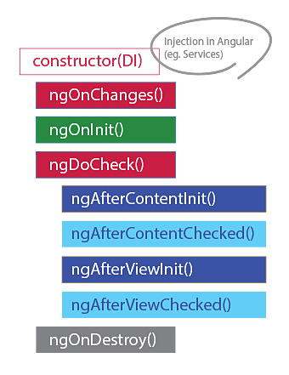

- ngOnChanges() :
Respond when Angular sets or resets data-bound input properties. The method receives a SimpleChanges object of current and previous property values.
Note that this happens very frequently, so any operation you perform here impacts performance significantly.
Timing :
Called before ngOnInit() (if the component has bound inputs) and whenever one or more data-bound input properties change.
Note that if your component has no inputs or you use it without providing any inputs, the framework will not call ngOnChanges().

Ex:

import { Input, SimpleChange, SimpleChanges } from '@angular/core';
import { Component, OnChanges } from '@angular/core';

@Component({
selector: 'app-ng-on-changes',
templateUrl: './ng-on-changes.component.html',
styleUrls: ['./ng-on-changes.component.css']
})
export class NgOnChangesComponent implements OnChanges{

@Input('name') name:any;
@Input('age') age:any;
constructor() { }

ngOnChanges(changes:SimpleChanges){
// const change1:SimpleChange=changes.name;
// const change2:SimpleChange=changes.age;
// console.log("ngOnChanges()")
// console.log(`Previous Value::${change1.previousValue}....Current Value::${change1.currentValue}`);
// console.log(`Previous Value::${change2.previousValue}....Current Value::${change2.currentValue}`);
for (const propName in changes) {
const chng = changes[propName];
const cur = JSON.stringify(chng.currentValue);
const prev = JSON.stringify(chng.previousValue);
console.log(`${propName}: currentValue = ${cur}, previousValue = ${prev}`);
}

}

}

Parent html
----------

<div class="row">

<input class="col-md-5 offset-1 border-danger" type="text" [(ngModel)]="name">

<input class="col-md-5 border border-info" type="number" [(ngModel)]="age">
</div>

<app-ng-on-changes [name]="name" [age]="age"></app-ng-on-changes>

<router-outlet></router-outlet>

- ngOnInit()
Initialize the directive or component after Angular first displays the data-bound properties and sets the directive or component's input properties.

Timing:
Called once, after the first ngOnChanges(). ngOnInit() is still called even when ngOnChanges() is not (which is the case when there are no template-bound inputs).

Ex:
ngOnInit(): void {
console.log("ngOnInit()")
}

Difference between constructor and ngOnInit in Angular
- We use constructor() for all the initialization of class members or variables.
- The constructor() should only be used to initialize class members and shouldn’t do other “work”.
- You can use constructor() to setup Dependency Injection so that you can Initialize class members.
- ngOnInit() is a better place to write other initialization tasks that we need to execute once the class is instantiated.
- For example, if you want to load data from Database in your HTML template view. Then such code should be written in ngOnInit() method.

Conclusion
- Constructor() should be used only for initialization of class members.
- ngOnInit() method should be used for other initialization tasks which need to be executed right after class is instantiated.

- ngDoCheck()

Detect and act upon changes that Angular can't or won't detect on its own.

To monitor changes that occur where ngOnChanges() won't catch them, you can implement your own change check

Timing:

Called immediately after ngOnChanges() on every change detection run, and immediately after ngOnInit() on the first run.

Ex:
ngDoCheck(): void {
console.log("ngDoCheck()");
}

4.ngAfterContentInit()

Respond after Angular projects external content into the component's view, or into the view that a directive is in.

Timing:
Called once after the first ngDoCheck().

Ex:

<app-life-cycle-methods [name]="name" [age]="age" >
<h1 #childTemp>{{salary}}</h1>
</app-life-cycle-methods>

@ContentChild('childTemp',{static:true}) salary:any;

ngAfterContentInit(): void {
console.log("ngAfterContentInit()"+this.salary);
}

5.ngAfterContentChecked()

Respond after Angular checks the content projected into the directive or component.

Timing:
Called after ngAfterContentInit() and every subsequent ngDoCheck().

Ex:
ngAfterContentChecked(): void {
console.log("ngAfterContentChecked() "+this.salary);
}

6.ngAfterViewInit()
Respond after Angular initializes the component's views and child views, or the view that contains the directive.

Timing:
Called once after the first ngAfterContentChecked().

Ex:
ngAfterViewInit(): void {
console.log("ngAfterViewInit() "+this.salary+"....."+this.company.nativeElement.value);
}

7.ngAfterViewChecked()

Respond after Angular checks the component's views and child views, or the view that contains the directive.

Timing:
Called after the ngAfterViewInit() and every subsequent ngAfterContentChecked().

Ex:
ngAfterViewChecked(): void {
console.log("ngAfterViewChecked() "+this.salary+"....."+this.company.nativeElement.value);
}

8.ngOnDestroy()

Cleanup just before Angular destroys the directive or component. Unsubscribe Observables and detach event handlers to avoid memory leaks.

Timing:
Called immediately before Angular destroys the directive or component.

Ex:
ngOnDestroy(){
console.log("ngOnDestroy() "+this.salary+"....."+this.company.nati veElement.value);
}

import { AfterContentChecked, AfterContentInit, AfterViewChecked, AfterViewInit, ContentChild, DoCheck, ElementRef, Input, OnDestroy, OnInit, SimpleChange, SimpleChanges, ViewChild } from '@angular/core';
import { Component, OnChanges } from '@angular/core';

@Component({
selector: 'app-life-cycle-methods',
templateUrl: './life-cycle-methods.component.html',
styleUrls: ['./life-cycle-methods.component.css'],
})
export class LifeCycleMethodsComponent implements OnChanges, OnInit , DoCheck,AfterContentInit,AfterContentChecked,AfterViewInit,AfterViewChecked,OnDestroy{
@Input('name') name: any;
@Input('age') age: any;
@ContentChild('childTemp',{static:false}) salary:any;
@ViewChild('company',{static:true}) company:ElementRef=new ElementRef(name);
constructor() {
console.log("Constructor()")
}

ngOnChanges(changes: SimpleChanges) {
// const change1:SimpleChange=changes.name;
// const change2:SimpleChange=changes.age;
// console.log(`Previous Value::${change1.previousValue}....Current Value::${change1.currentValue}`);
// console.log(`Previous Value::${change2.previousValue}....Current Value::${change2.currentValue}`);
console.log("ngOnChanges()")
for (const propName in changes) {
const chng = changes[propName];
const cur = JSON.stringify(chng.currentValue);
const prev = JSON.stringify(chng.previousValue);
console.log(
`${propName}: currentValue = ${cur}, previousValue = ${prev}`
);
}
}

ngOnInit(): void {
console.log("ngOnInit() "+this.salary+"....."+this.company.nativeElement.value);
}

ngDoCheck(): void {
console.log("ngDoCheck()....."+this.company.nativeElement.value);
}

ngAfterContentInit(): void {
console.log("ngAfterContentInit() "+this.salary+"....."+this.company.nativeElement.value);
}

ngAfterContentChecked(): void {
console.log("ngAfterContentChecked() "+this.salary+"....."+this.company.nativeElement.value);
}

ngAfterViewInit(): void {
console.log("ngAfterViewInit() "+this.salary+"....."+this.company.nativeElement.value);
}

ngAfterViewChecked(): void {
console.log("ngAfterViewChecked() "+this.salary+"....."+this.company.nativeElement.value);
}

ngOnDestroy(){
console.log("ngOnDestroy() "+this.salary+"....."+this.company.nativeElement.value);
}
}

App.component.html
--------------------

<div class="row">

<input class="col-3 offset-1 border-danger" type="text" [(ngModel)]="name">

<input class="col-3 offset-1 border border-info" type="number" [(ngModel)]="age">

<input class="col-3 offset-1 border border-info" type="number" [(ngModel)]="salary">
</div>

<app-life-cycle-methods [name]="name" [age]="age" >
<h1 #childTemp>{{salary}}</h1>
</app-life-cycle-methods>

<router-outlet></router-outlet>

Angular flex layout
Angular flex layout features divided into two main categories
- Static API
- Responsive API
Each API has its own directives or APIs which can be applied on flexbox container or flexbox child elements.
- Flex Parent Directives
- fxLayout
- fxLayoutAlign
- fxLayoutGap
- Flex Child Directives
- fxFlex
- fxFlexOrder
- fxFlexOffset
- fxFlexAlign
- fxFlexFill
fxLayout

- fxLayout is a directive and it is case sensitive
- fxLayout is used ti define the layout of the HTML element i.e it is decides the flow of the child element with in a flex container
- fxLayout allowed values are row(default),column,row-reverse,column-reverse
- fxLayout is applied on parent element

fxLayoutAlign

- fxLayoutAlign directive defines alignment of children element within the flexbox parent container, We can see the alignment of both main-axis and cross-axis
- Main Axis values are -- start , center , end , space-between ,space-around,space-evenly
- Cross Axis Values are -- start , center , end , space-between ,space-around,baseline , stretch
<div class="container" fxLayout="row" fxLayoutAlign="center center" fxLayoutGap="30px">
<p class="one">One</p> Main Axis Cross Axis
<p class="two">Two</p>

<p class="three">Three</p>
</div>

--> In the above example Main Axis will work , if the fxLayout is row or row-reverse, Same way Cross Axis will work if the fxLayout is column or column-reverse.

fxLayoutGap: It is for establishing the gaps between child elements within the flexbox parent container

fxFlex: It is for re-sizing the child elements within the flexbox parent container

fxFlexOrder: It is for mentioning the order of child element among the child elements of the flexbox parent container
fxFlexOffset: It is for setting the distance for an child element from other child elements within flexbox parent container
fxFlexAlign: It works like fxLayoutAlign , but applicable only for one child element
fxFlexFill: Maximizes the width and height of an element in a layout container.
Ex:
<div class="container" fxLayout="row" fxLayoutAlign="center space-around" fxLayoutGap="30px">
<div class="one" fxFlex="100px" fxFlexOrder="1" fxFlexAlign="end">One</div>
<div style="background-color: cyan;" fxFlex="140px" fxFlexOrder="2" fxFlexOffset="30px" fxFlexAlign="start">Two</div>
<div class="three" fxFlex="150px" fxFlexOrder="3" fxFlexOffset="30px" fxFlexFill>Three</div>
</div>

<div class="flex-container" fxLayout="row">
<div class="child-1" fxFlex="1 2 auto">
Angular fxFlex flexgrow flexshrink flexbasis </div>
<div class="child-2" fxFlex="1 1 auto">
Angular fxFlex flexgrow flexshrink flexbasis </div>
</div>

Both flex items has flex grow value as 1. That means if there is enough space both items will have same width.
The first flex box item has a shrink value 2.
As the width of the flex container decreases, the first element will shrink more when compared the second one based upon the available space.
As long as there is enough space inside the container the both flex items try to maintain same width.

